Engineering intrinsic π-electron magnetism in atomically-precise carbon nanostructures
Roman Fasel
Empa, Swiss Federal Laboratories for Materials Science and Technology, nanotech@surfaces Laboratory, Überlandstrasse 129, 8600 Dübendorf, Switzerland
Topologies of the edge bonds and π-electron network critically influence the electronic structure of finite size graphene fragments such as nanographenes and graphene nanoribbons. Among various properties that arise in such carbon nanomaterials, intrinsic magnetism is a particularly attractive one [1]. Given the weak spin-orbit and hyperfine couplings in carbon and the possibility of electric-field control of spin transport, realization of magnetic carbon nanomaterials may offer unique opportunities in spintronic applications.
In this presentation, I will discuss the on-surface synthesis and scanning probe microscopy / spectroscopy characterization of nanographenes with structural topologies entailing intrinsic π-magnetism. I will present a non-Kekulé compound (Fig. 1) in which magnetism arises due to topological frustration of the π-electron network [2], and report on recent progress towards all-zigzag nanographenes [3]. Finally, two complementary approaches to molecular spin chains will be discussed. While the first approach is based on the covalent interlinking of triangular nanographenes [4], a promising alternative builds on topological electronic quantum phases in edge-extended graphene nanoribbons [5].
[1] O.V. Yazyev, Rep. Prog. Phys. 73, 056501 (2010).
[2] S. Mishra et al., Nat. Nanotechnol. 15, 22 (2020).
[3] S. Mishra et al., arXiv:2003.03577 (2020).
[4] S. Mishra et al., Angew. Chem. Int. Ed. 59, 12041 (2020).
[5] O. Gröning et al., Nature 560, 209 (2018).

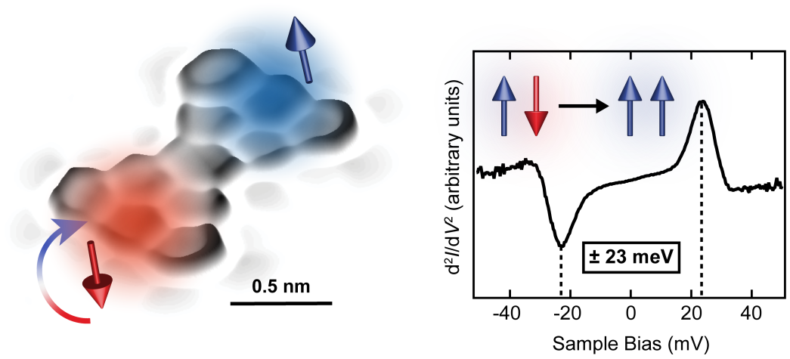
Figure 1: Left: 3D-rendered high-resolution scanning tunneling micrograph of Clar’s goblet. The spin excitation process is schematically illustrated, where the lower spin (initially pointing down) is flipped up (blue arrow: spin up, red arrow: spin down). Right: Experimental inelastic electron tunneling spectrum of Clar’s goblet. The peaks in the spectrum (marked by dashed lines) correspond to the threshold energy of 23 meV required for the schematically illustrated spin excitation.

