Section Sciences et Ingénierie de l’Environnement | 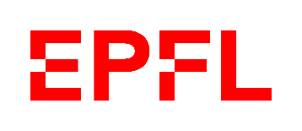

Evaluation form for the Design Project 2023
Form for internal use, to be kept by the EPFL supervisor
Final grade to be sent to the Academic Service by the EPFL supervisor.
Deadline: Monday 17th July 2023

Project’s title :
Students : 1.  2. | Supervision : EPFL teacher :  Supervisors from the company :

 |  |  | Coherence between content and developed proposal | Organization and respect of deadlines |  | Grade
Project’s proposition | 10% | Company
 |  | EPFL

 |  |  | Content consistency | Writing quality, presentation | Project management, initiative, independance | Grade
intermediate report | 15% | Company |  |  | .
 |  | EPFL
 |  |  | Coherence and mastery of the topic | Quality of the presentation and answers to questions |  | Grade
oral presentation | 25% | Company |  | .
 |  | EPFL |  | .

final report | 50% | Company
 |  | EPFL
TOTAL | 100% | Company
 |  | EPFL
Final grade is rounded to the quarter point (0.25):

