MERLIN magnification and image calibration wrong:

An error occurred during the SmartSem software update date on Oct n10th 2014:

The output device calibration was lost.

This calibration affect directly the image magnification and scale bar displayed on the screen and stored into the TIF image for users using “Output Device” as reference magnification (which is the default setting).

This was only recently discovered by one of the MERLIN user and it has been corrected on Friday morning January 16th.

We do apology for this problem.

To check if your images are calibrated correctly or not, you can follow the description below. To do that for windows user, please first download and install Notepad++ from the web.

Check your image:

- Run Notepad++ (Windows) or TextEdit (MAC OS X)

- Open your image to check with the editor

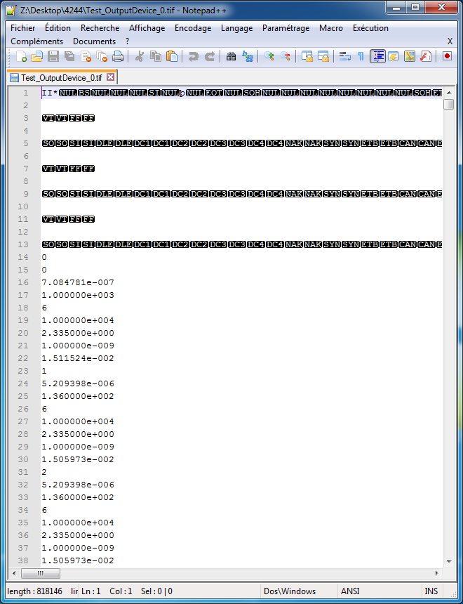  Notepad++ sample | 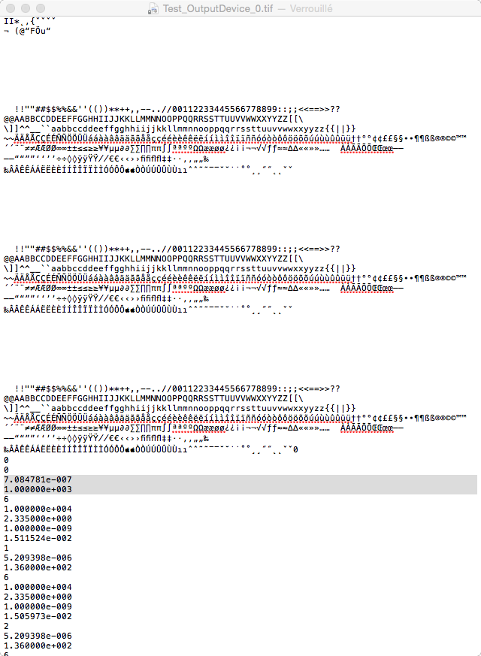  TextEdit sample

- Search into the file the following entry “Reference Mag =”. If the value is “Out Dev.” your images are affected by the wrong calibration and you should apply the following procedure, otherwise you are not concerned by the problem.

If your images are affected do the following:

- Search for line 16 (MAC shortcut cmd+L).

- Please multiply the value located on line 16 by the value on line 17 and divide the result by 2.812499e-004
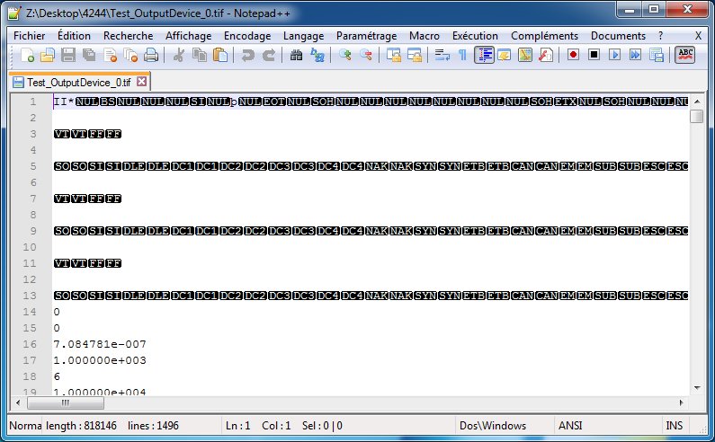
(7.084781e-007 * 1.000000e+003) / 2.8125e-004

If the result is 1.00 (only two digit after comma) your image is correct and is not concerned by the wrong calibration and you can stop here. If the result is different, please continue.

Modifying the scale bar of your image

This needs to be done ONLY if you are sure that your image is concerned by the wrong calibration, otherwise you will corrupt your image.
The following points will not change the information on the existing data bar of your image. This will only give you the possibility to correct the scale bar by inserting a new one and/or do new measurements on your image.

- Run Notepad++ (Windows) or TextEdit (MAC OS X) editor.

- Open your image containing the wrong calibration with the editor.

- Search for line 16 (MAC shortcut cmd+L).

- Divide the value on line 16 by 2.519033244

in this example: 7.084781e-007 / 2.519033244 = 2.8125e-007

- Replace the value at line 16 by the result with 6 digits after the decimal point. 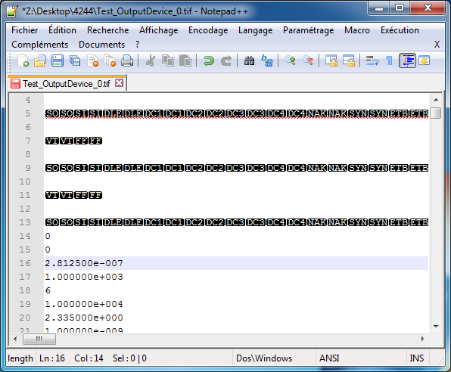

- Save the file as TIF file by changing the name.
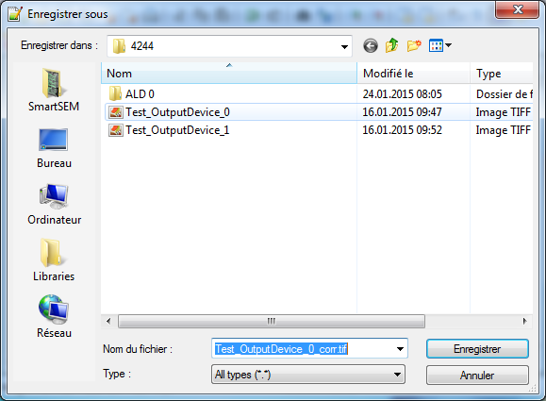

- Re-open your saved image with SmartSem or SmartTiff. Now you can place a new scale bar and/or new measurement annotation on your image. Unfortunately, the data zone on your image can’t be replaced or modified.

