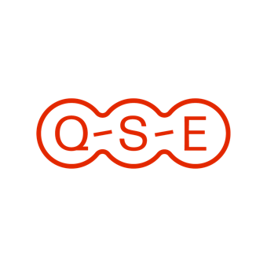
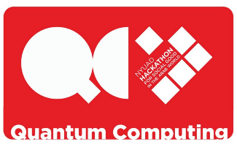
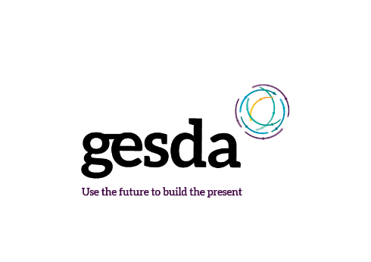

Application Form - Quantum Hackathon 2024

The Quantum Hackathon 2024 is an initiative of the Open Quantum Institute of GESDA and New York University Abu Dhabi as organizing partner. The EPFL Center for Quantum Science and Engineering (QSE) is sponsoring one student of EPFL.

Personal Details:
First Name
Last Name
Level | BSc | MSc | PhD
Motivation Abstract (max. 500 words):
Please insert your text here.
“How will quantum computing impact one of the SDGs in 5, 10 or 25 years, and what are the non-technological conditions necessary to realize the impact on the ground?”
+ A short paragraph on your technical background with designing quantum algorithms.

Please combine the following documents to one PDF file:
- This page including Personal Details and Motivation Abstract.
- Short CV (one page)
- Transcript of Grades
To submit your application, send the single PDF file to qse@epfl.ch

