HRC Living Lab Grants 2021

Hidden Rivers as social, spatial and ecological continuities in the Lausanne-Morges Agglomeration
2021 Call for proposals – Guide for Applicants – Deadline 01.09.2021 (12:00 CET)

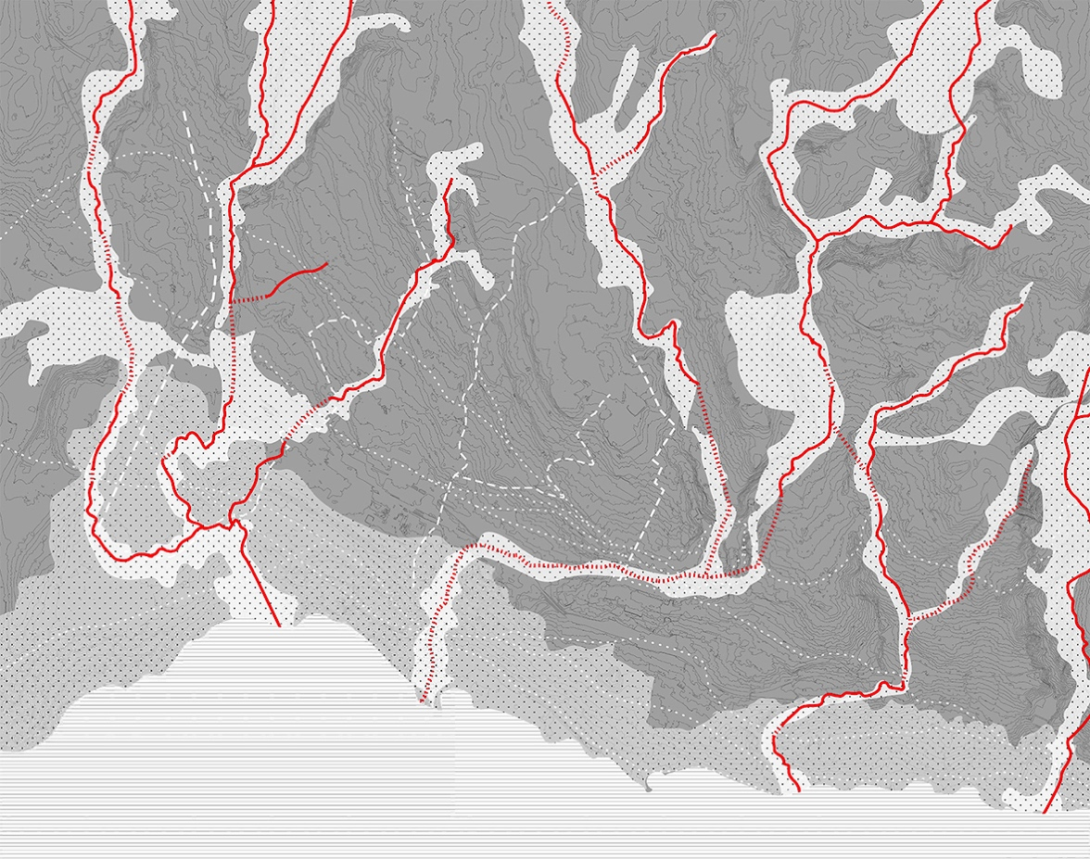
Credit: Source image: EPFL Lab U, Studio Hidden Rivers, BA5-6 2020-2021

- Introduction
By 2050, two third of the world’s population will live in urban areas and face increased challenges, climate and socio-demographic changes, entailing a large-scale spatial and socio-ecological transition. Extended urbanization redefines the interaction between rural and urban, between nature and cities, transforming ecologies, mobility, agricultural production and life styles. In this context, Habitat Research Center aims at reinforcing synergies at the ENAC and EPFL levels, and between academia and society, around a major topic: URBANIZATION IN THE SOCIO-ECOLOGICAL AND SPATIAL TRANSITION, through action-oriented and interdisciplinary design research.
To encourage ENAC and EPFL scientists to focus on the convergence of sustainability, transdisciplinarity and urbanization in transition, the Habitat Research Center has decided to launch for the first time a call for “HRC Living Lab grants”. The call opens on June 9, 2021, and closes on August 12, 2021.

- Mission and topic of the call
The general mission of this call is to (I) promote transdisciplinary collaboration through research and design within the framework of the Lausanne-Morges Agglomeration as Living Lab (see 2.1) and to (II) explore opportunities and challenges of urbanization in transition related to the theme of “Hidden Rivers” as social, spatial and ecological continuities within the urban and natural environments (see 2.2). The call aims at enabling problem-driven and application-orientated research efforts for sustainable urban and rural development.
This call will support up to three transdisciplinary projects (30k CHF for each project). We expect applicants to explore, initiate, and/or participate in new types of collaborations. The application should involve two principal investigators (PIs), who are early-career scientists and who will collaborate with minimum one partner outside academia in the larger and integrative framework of the Lausanne-Morges agglomeration that will serve as Living Lab.

2.1 Transdisciplinary research: The Lausanne-Morges Agglomeration as Living Lab
When addressing the topics of urbanization in transition and sustainable urban-rural development, transdisciplinarity is increasingly mentioned as a promising way of producing knowledge and decision-making, and often characterized by the inclusion of non-academic stakeholders in the process of knowledge production.
The HRC has selected the Lausanne-Morges agglomeration as living lab for the implementation of this grant: a main territory and case-study on which all proposals are invited to focus. According to the European Network of Living Labs (ENoLL), “living Labs are defined as user-centered, open innovation ecosystems based on systematic user co-creation approach, integrating research and innovation processes in real life communities and settings. (… Living Labs) operate as intermediaries among citizens, research organisations, companies, cities and regions for joint value co-creation, rapid prototyping or validation to scale up innovation and businesses.”
Within this spatial framework and network of actors, applicants are invited to build research consortia including minimum one non-academic partner. Applicants are entirely free to identify and involve any non-academic partner who is active in the Lausanne-Morges agglomeration and the activity of whom is relevant for the project idea. However, HRC have already identified a series of stakeholders (i.a cantonal and (inter)communal offices, citizen associations and actors of the cultural world) likely to be interested in a transdisciplinary research initiative on urbanization in transition in the Lausanne-Morges agglomeration (see below section 7. How to apply and timeline).
During the application phase, this living lab format will enable the HRC team to facilitate and promote matchmaking between academic applicants and non-academic partners in the Lausanne-Morges agglomeration (see below section 7. How to apply and timeline). During the research development phase, the HRC team will set up a coordination between the selected projects in the form of a series of Living Lab seminars, in order to provide methodological inputs, as well as to promote ideas, data and resources sharing, synergies between the projects and complementarity of findings.

2.2 Urbanization in the socio-ecological and spatial transition: Hidden Rivers as social, spatial and ecological continuities within the urban and natural environments
In order to address the topic of urbanization in the socio-ecological and spatial transition, HRC has defined a general theme for the Living lab grants: Hidden Rivers as social, spatial and ecological continuities within the urban and natural environments.
This theme aims at exploring the presence/absence of rivers in the Lausanne-Morges agglomeration as natural ecosystems, cultural landscapes and hydraulic infrastructures within the city. Historically, rivers served as a vital resource and as one of the most important links between inhabitants and the natural environment. Nevertheless, due to the push towards industrialization and urbanization across territories, these rivers have become largely channelized and buried, within increasingly fragmented surrounding spaces.
The HRC Living Lab Grants wishes to (re)open research and design perspectives regarding the presence/absence of hidden rivers and the role they can play in the future sustainable redevelopment of the Lausanne-Morges agglomeration. This call for proposals is an opportunity to rethink the relationship between the city, the valleys and its waterbodies. The question of the continuity within the urban and natural environments shall be addressed as a social, spatial and ecological project.
The various aspects of this challenge relate to risk management, to mitigative and adaptive climate change strategies; and to the demographic, social and economic evolution of inhabited and productive spaces. Applicants are entirely free to propose an original project idea in relation to the general theme of “Hidden Rivers” and to the challenges of urbanization in transition. However, HRC suggests three non-exhaustive and interrelated sub-themes that can inspire and guide applicants in developing their project idea:
- A. Renaturation, demineralization, water/soil quality, management of contamination, flood water management, support for biodiversity
- B. Health, soft and active mobility, heat island mitigation, inclusion of vulnerable people
- C. Urban metabolism, water as a resource, urban agriculture

- Eligibility and Requirements
- The application should involve a research consortium including:
  - Two Principal Investigators (PIs), with minimum one Principal Investigator (PI 1) affiliated to an ENAC Laboratory. The second Principal investigator (PI 2) can be affiliated to an ENAC or EPFL Laboratory;
  - Minimum one non-academic partner from the Lausanne-Morges agglomeration.
- The PIs should be early-career researchers (i.e. PhD or Postdoc or scientific collaborator). The two PIs must be experts in two different disciplines and their project idea must address a transdisciplinary research field(s). The PIs can be affiliated to the same institute or faculty provided their disciplines are different. The Head of the host lab of each PI will act as supervisor and should provide letters of support (template available in the Application toolkit).
- The non-academic partner(s) can be from the private or public sector, governmental or non-governmental (i.a cantonal and (inter)communal offices, consulting firm, citizen associations and actors of the cultural world, etc.). The non-academic partner(s) must be active in the Lausanne-Morges agglomeration and its activity must be relevant for the project idea, in relation to the topic and theme of the call. The PIs (or supervisors of the PIs) can have already ongoing collaborations with the non-partner(s), but these should be specified in the application form (under 12.2). The non-academic partners should provide a letter of support (template available Application toolkit). The non-academic partner cannot receive direct funding through this grant.
- PIs can be involved in only one proposal for this call.
- Members of the HRC scientific board can only be supervisor of one proposal for submission to this call.
- The projects proposed for this call must be an original idea and research operation(s).
- An application with the same proposal idea should not be submitted to one of the other ENAC sustainability grant calls 2021 (see website).PIs that are involved in an ENAC sustainability grant proposal 2021 are eligible to apply as long as the research/project idea is different from the submitted ENAC sustainability grant; an extra justification on the differences is to be given in the application form (under 12.2).
- An Ethics Form is to be filled out by the PIs and an ethics self-assessment is to be submitted if the answer is ‘yes’ to one or several questions in the Ethics Issues Table. Applicant should include any supporting documentation, such as any authorizations, as this will allow a more effective ethics clearance during the granting process. Applicant can find more information to write an ethics self-assessment in the Ethics form and on this dedicated website.
- The proposal's content should be related to the mission of the call and the application and related annexes must meet all above eligibility requirements. If it becomes clear before, during or after the review evaluation phase, that one or more of the eligibility criteria has not been met, the proposal will be declared ineligible and rejected by the HRC Living Lab Grant Selection Committee. The PI declares when submitting that the information contained in their application is correct and complete.

- Eligible costs
- The total maximum requested grant is 30kCHF for each project, and the maximum grant duration is 1 year.
- If properly justified, costs for the following categories can be requested:
    - Salary costs for PIs; Salary costs to hire research and/or student assistants (in compliance with EPFL LEX 4.7.1)
    - Travel and conference/seminar fees
    - Consumables
    - Internal invoices for use of common EPFL research facilities
    - Other general costs linked to small equipment, software, publications, workshops, outreach, etc.
    - Subcontracting fees, corresponding to no more than 15% of the requested amount
- No overhead shall be paid for the HRC Living Lab grant funded projects
- The distribution of the requested costs between the 2 PIs is flexible, but should be consistent with the project idea and proposed methodology. The non-academic partners cannot claim any costs directly to this grant.

- Evaluation criteria
- Project idea: Link to theme (hidden rivers) and general topic (urbanization in transition) of the call; Originality and goals of the proposed transdisciplinary approach; Added value and relevance of the research consortium (including collaboration with non-academic partner(s) in the living lab).
- Methodology: Relevance of the proposed methodology, tasks and research operations; feasibility.
- Impact: Impact on societal problems; Solution implementation.
- Outreach and actions: Envisaged communication and dissemination activities; Envisaged 1:1 scale experimentation(s).

- All proposals will be reviewed and ranked by the HRC Living Lab Grant Selection Committee (composed by the HRC scientific board, with one representative of the ENAC faculty and two non-academic representatives in the Lausanne-Morge Agglomeration living lab).

- Proposal documents (see Application toolkit)
- Application form and research plan
- Annex 1: CV of the PI 1 (SNSF format)
- Annex 2: CV of the PI 2 (SNSF format)
- Annex 3: PI 1’s supervisor support letter (head of ENAC lab)
- Annex 4: PI 2’s supervisor support letter (head of ENAC or EPFL lab)
- Annex 5: Support letter of the non-academic partner(s)
- Annex 6: Ethics form (with an ethics self-assessment if applicable)

- How to apply and timeline
- Information: HRC will organize and participate in various public events during which the format of the grants (living lab), as well as the theme (hidden rivers) and potential matchmaking with non-academic partners will be presented
  - June 10th 2021: ENAC Research Day, Networking groups
  - June 10th 2021: New Climates in... Lausanne: Hidden Rivers
  - July 5th 2021: HRC Day, Morning session
- Matchmaking: During the development of their project idea, applicants are kindly invited to contact the HRC team who will put them in touch with non-academic partners potentially interested in a research collaboration on different sub-themes related to the "Hidden Rivers" theme. Please contact via email: habitat-grants2021@epfl.ch.
- Proposals should be submitted to habitat-grants2021@epfl.ch by September 1st, 2021, 12:00 CET.
- Please use the provided templates (see Application toolkit) for your application form and research plan, CV(s) (Annexes 1 and 2 - SNSF format), support letters (Annex 3, 4 and 5) and Ethics form (Annex 6)
- Please add “HRC Living Lab Grant application_NAME” in the title of the submission email.
- Submission deadline: September 1st, 2021
- Earliest project start: October 2021 at the earliest, December 2021 at the latest

- Start of the funding period
- If a project is selected, a data management plan, describing the FAIR principle, has to be submitted within the first 3 months of the project.
- A collaboration agreement between the EPFL grantee(s) and the project partner(s) must be signed within three months of the start of the project (via the EPFL DAR Legal Affairs). The agreement will define the rights and obligations of the parties. It may allow data exchange, and will specify all relevant conditions. The projects must comply with the Directive concerning research integrity and good scientific practice at EPFL (LEX 3.3.2) and the Directive on Grants, Research Contracts and Technology Transfer (DSCRTT – LEX 3.4.1).
- A short report outlining the project progress and actual cost expenses linked to the project activities will be asked at the end of the project.

- Contact
For any questions related to the call 2021, please contact via email: habitat-grants2021@epfl.ch.
HRC will compile all questions and address them on the dedicated website.

