Student Project Proposal
Project title: : Metasurface based biosensor
Project type: Bachelor Semester Project
Faculty and Laboratory: STI, Microwaves and Antennas Group (MAG)
Contact: Anja Skrivervik – anja.skrivervik@epfl.ch
Behnaz Bakhtiari – behnaz.bakhtiari@epfl.ch

Project description:
Wearable sensing technologies have emerged as a transformative approach for non-invasive, real-time monitoring of physiological and biochemical markers in human health. Among the various biofluids, sweat has gained significant attention due to its rich composition of electrolytes, metabolites, hormones, and small molecules that provide critical insights into an individual’s health status [1]. Advances in wearable sweat sensors have enabled the detection of biomarkers such as glucose, lactate, sodium, potassium, cortisol, and pH, paving the way for applications in fitness monitoring, disease diagnosis, and personalized medicine [2].
In this project, we design a structure base on metasurfaces to detect biomolecules in sweat. monitoring the biomolecule density changes in sweat dynamically. Since based on the recent research, finger tip has the most density of sweat, so we design the structure with proportional dimensions and conformal shape of the finger.
Type of work:
- Theory and simulation: 75 %
- Documentation and reporting: 25 %.

Student tasks:
- Design and simulate the curved shaped metasurface based biosensor

Fig.1. Biosensor on the Finger. | Fig.2. Designed Flat Structure
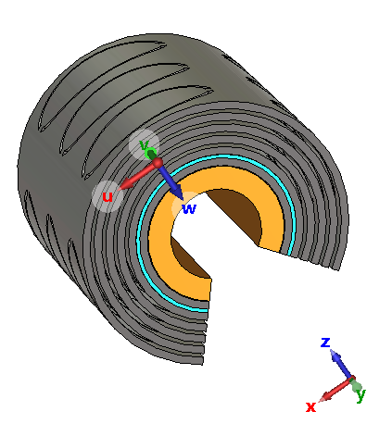

Fig.3. Curved Metasurface based Wearbale Biosensor

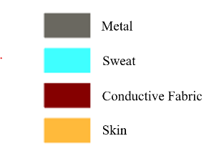
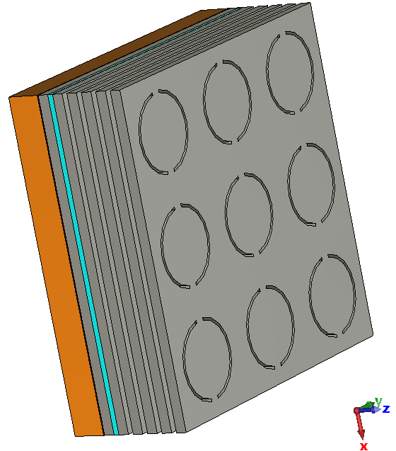
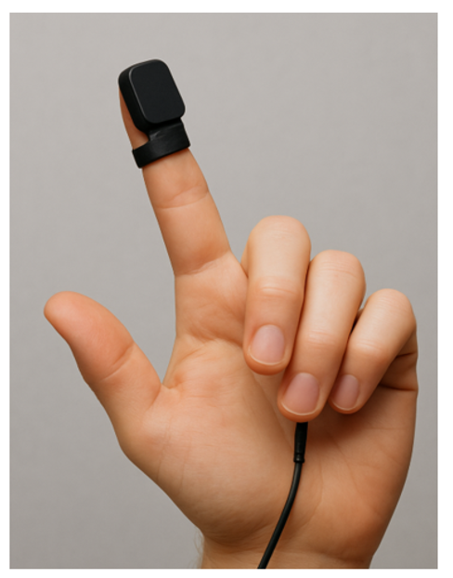
References:
[1] Bandodkar, A. J., & Wang, J. (2014). Non-invasive wearable electrochemical sensors: a review. Trends in Biotechnology, 32(7), 363-371.
[2] Gao, W., Emaminejad, S., Nyein, H. Y. Y., Challa, S., Chen, K., Peck, A., ... & Javey, A. (2016). Fully integrated wearable sensor arrays for multiplexed in situ perspiration analysis. Nature, 529(7587), 509-514.

