Student Project Proposal

Project title: Understanding When Radiation Occurs: The Role of Discontinuities
Faculty and Laboratory: STI, Microwaves and Antennas Group (MAG)
Contact: Prof. Anja Skrivervik anja.skrivervik@epfl.ch
Amir Ahmadi amir.ahmadi@epfl.ch
Level: Bachelor Semester Project (8 Credits)
Project Description:
In antenna theory, a fundamental question concerns the radiation mechanism—specifically, how electromagnetic fields detach from an antenna and propagate into free space. This process can be effectively illustrated by analyzing a single wire. An examination of the current distribution shows that radiation requires a time-varying current or the acceleration of charge. As a result, radiation along a wire typically occurs at points of curvature, bends, terminations, or other discontinuities.
This project focuses on analyzing discontinuities, as they provide a mechanism for radiation without requiring physical deformation of the structure—an essential consideration in spatially constrained applications. Since the geometry and properties of discontinuity directly influence the resulting electromagnetic fields, the goal of this project is to investigate the discontinuities present in a circularly formed cable (as shown in Figure 1) and to establish a theoretical framework for identifying the configurations that best optimize radiation performance. The project objectives are as follows:
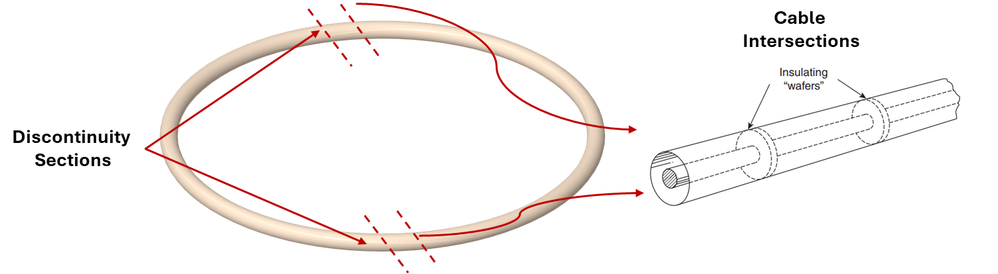
Figure 1 Illustration of the study assembly.

• Investigate fundamental radiation mechanisms: Analyze the underlying physics of electromagnetic field detachment and identify the theoretical figures of merit associated with single-wire radiation.
• Analyze discontinuity configurations: Examine and categorize various types of structural discontinuities applicable to cylindrically formed cables.
• Establish a comparative benchmark: Develop a framework to evaluate and compare the radiation efficiency and impedance characteristics of different discontinuity-based radiation methods.
• Validate through simulation and measurement: Support the theoretical findings through numerical modeling and experimental verification.

