Send Assist call : Press the red button

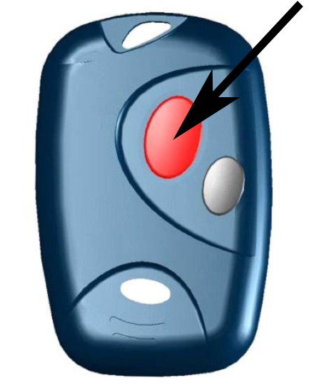

If an alarm was sent by error:
because of bad manipulation or automatic man - down
Please call at No. 115 emergencies centre,
and announce the error to operator

Man – Down Operation

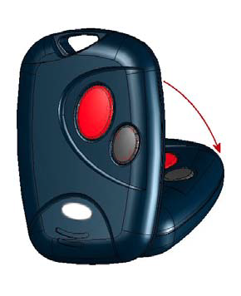

To prevent the automatic man-down alarm being sent, keep the DATI in an upright position (normally worn in the DATI holster on a belt)

If the DATI is not kept in an upright position, you will hear a beep and an alarm will be sent to the emergency centre after a few seconds.

If an alarm was sent by error:
because of bad manipulation or automatic man - down
Please call at No. 115 emergencies centre,
and announce the error to operator

