Periodic Structures - Volume gratings

1. Cascade of two thin gratings
2. Bragg condition
3. Angular selectivity
4. Holographic memories and filters (ppt)

In this lecture we will consider inhomogeneous structures with periodic spatial modulation of the dielectric constant. Such “volume gratings” are interesting in practical applications as optical filters for example. Periodic inhomogeneous media are often called photonic crystals since the periodic modulation of the medium properties modifies the propagation of the optical wave. In this way structure rather than chemical composition defines the optical properties of the crystal.

A cascade of two gratings:

We will start with a familiar situation: Two periodic gratings of period separated by a distance and illuminated by a plane wave with wavevector. (see *Figure 1*). The optical wave immediately following the first grating is described by



Assuming the system is infinite in y and then the envelope (in others words suppressing the time dependence) of the light distribution in the region between the two gratings is



gn is the amplitude of the nth order of the Fourier series describing the grating. The superscript n on the z component of the wave-vector indicates that the propagation constant depends on the direction of propagation of each of the diffraction orders:



Assuming z=0 is the z position of the first grating then the light immediately after the second grating is



For z>d the light distribution is



where . This is starting to look a bit too complicated. Let’s try to simplify before we lose track. For all the terms in the double summation for which n=-m the net field is a plane wave propagating along the direction of the illuminating field. All the term for which n+m=-1 contribute to the description of a plane wave that propagates in the direction of the -1 order of each of the two gratings. The simplest case is when which is true for weak gratings and in this case we can consider only the terms in the double sum above.



The first term corresponds to the portion of the incident wave that gets transmitted straight through both gratings undiffracted (see Figure1).

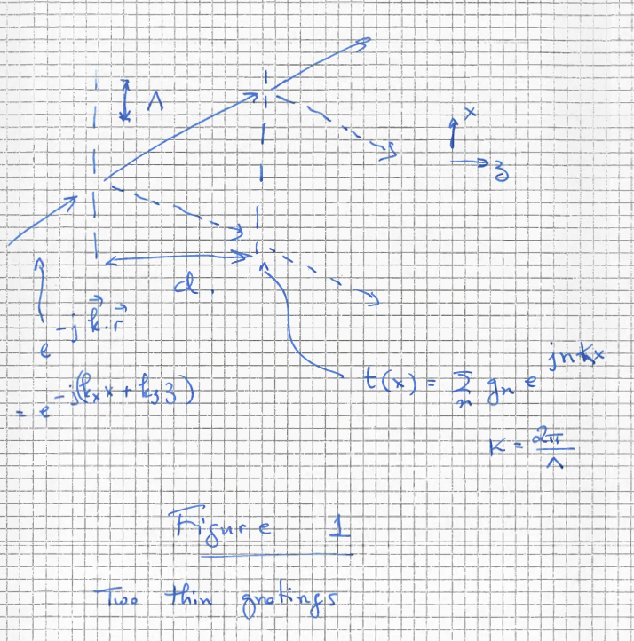

It propagates it the same direction as the incident wave since



and it is slightly depleted because of the missing light into the diffracted orders. This depletion is expressed by the product gogo. Notice that the 4th term also has the same wavevector. The fourth term describe the light diffracted into the +1 order by the first grating (upwards in Figure 1) and then diffracted again into the -1 diffraction order of the second grating (back down in Figure 1). Normally this doubly diffracted light would be weaker than the “ballistic” (undiffracted) beam

( ). Notice that the two beams will interfere as they propagate in past z=d and they will be a relative phase delay between due to the term . For certain distances d there will be destructive interference between the two beams.



The second term is the light diffracted by the first term that propagates ballistically through the second grating. It propagates in the same direction as the +1 order.



The 2nd and 3rd beams propagate in the same direction but they also have a relative phase shift between them



Under the condition



the two diffracted beams interfere constructively independently of the distance d that separates the tow gratings. This condition is called the “***Bragg condition”*** and it specifies the angle of illumination into a periodic structure that allows strong diffraction into one of the diffraction orders.

Notice that the Bragg condition does not depend on the distance d that separates the two gratings. Therefore we could have placed the second grating anywhere and the two 1st order diffracted beams would interfere constructively. Actually we can place any number of gratings with period in the path of the beam and all the diffracted beams will interfere constructively. We can therefore think of a “thick grating” or a continuous medium that is periodically modulated in x.



Propagation in thick gratings

We will use the BPE to simulate the propagation of light through thick media. We will set the dielectric constant to be



In Figure 2 the light distribution for a thick grating is shown.

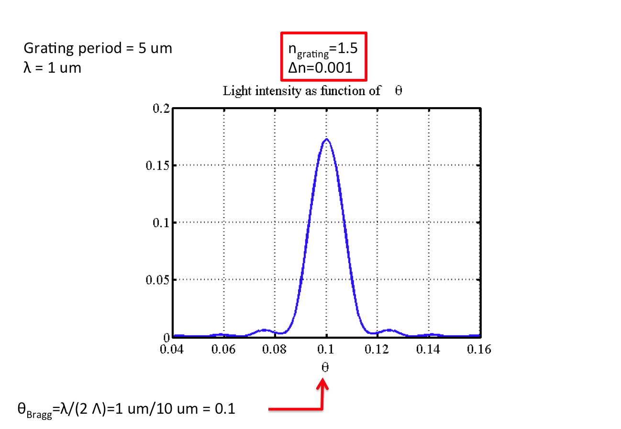

1. **Light intensity of the 1st order as a function of incident angle. The light intensity is maximized at θ=0.1=θBragg**

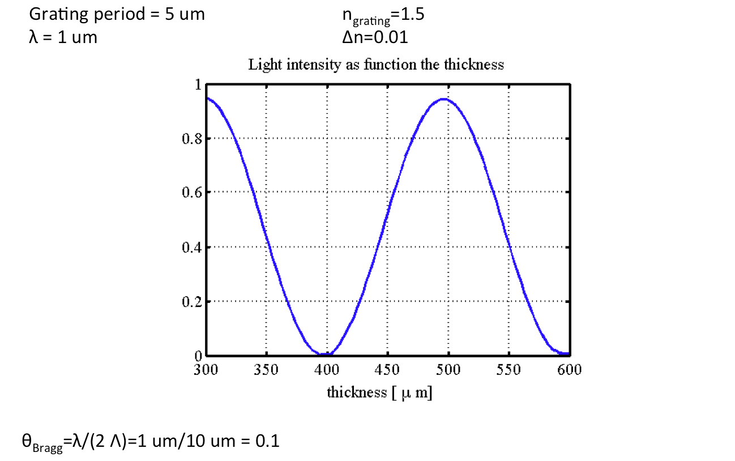

1. **Light intensity of the 1st order as a function of thickness d under the Bragg condition.**

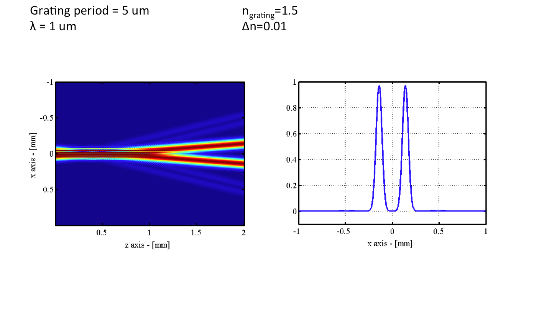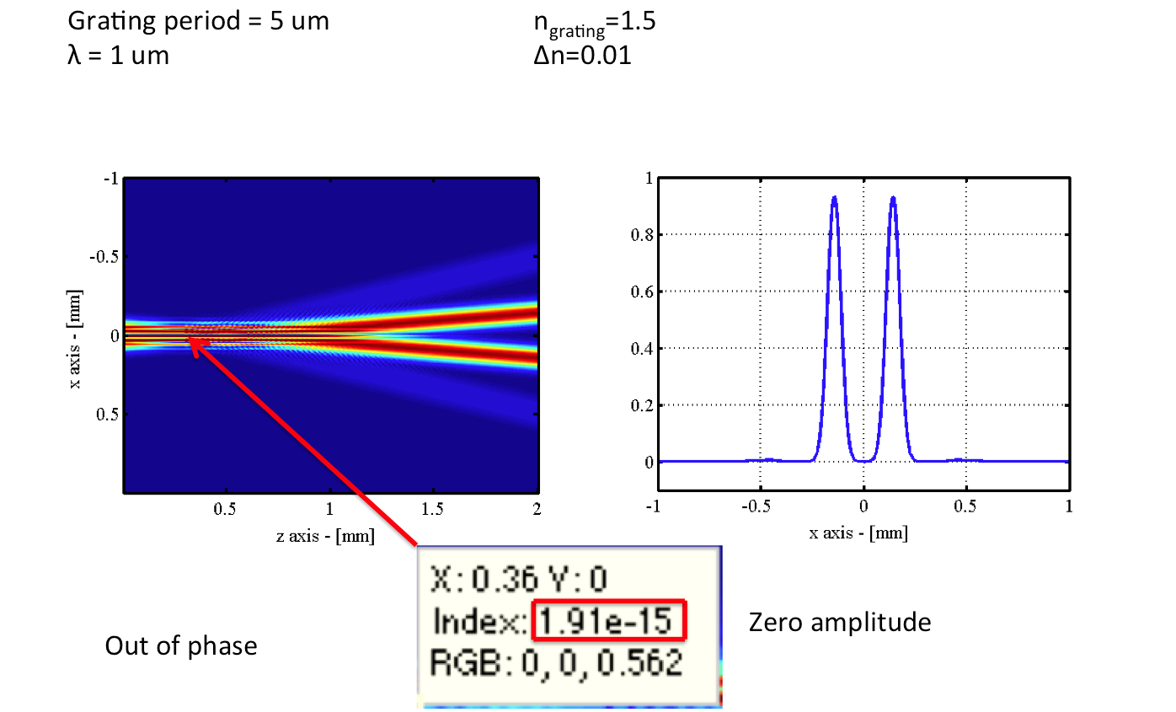

1. **Light distribution for an input of the form cos(Kx) where K is chosen to be at the Bragg angle for both sides of illumination. The two beams constructively interfere and reach the output plane. If the two inputs are out of phase, there will be zero amplitude along the optical axis because of destructive interference.**

Bragg-Matched read-out

We can analyze a thick grating by considering as a cascade of an infinite number of thin gratings and then integrate the diffraction of all the gratings. See Figure 3*.*

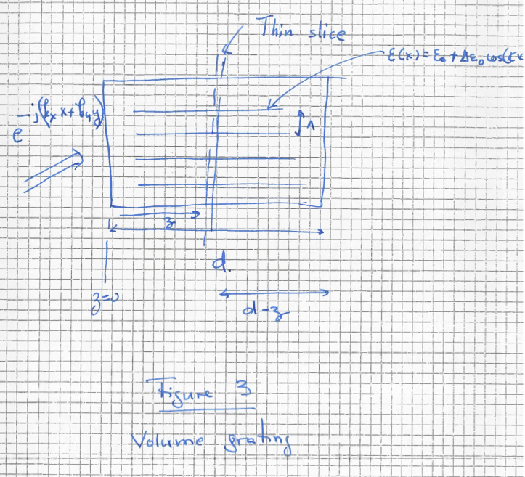

Let the incident illumination be . This represents a plane wave propagating to the right and upwards. The 1st order diffracted beam right after the “thin” grating at z is



The light amplitude of the 1st diffraction order at z=d after propagating from z to z=d is



The total light amplitude propagating in the direction of the 1st diffracted order can be found by integrating the diffracted light for all z





At the Bragg condition



and therefore he integral over z becomes equal to d. The diffracted wave is a plane wave in the direction of the 1st order whose amplitude grows with d. We know that this cannot happen indefinitely as d grows and therefore it must be an approximation somehow. What is the approximation? We assumed A0 is a constant whereas it must decay with z to allow for energy to be coupled to the A1. We can correct for that by realizing that



We can now use this expression in the integral over z above:



Solution:



Angular selectivity

When the Bragg condition is not satisfied due to a small angular deviation in the incidence angle we can derive a closed form solution for the diffracted light:



FOR THE 3D DISPLAYS READ FROM THE FOLLOWING LINK:

<https://www.osapublishing.org/aop/abstract.cfm?URI=aop-5-4-456>