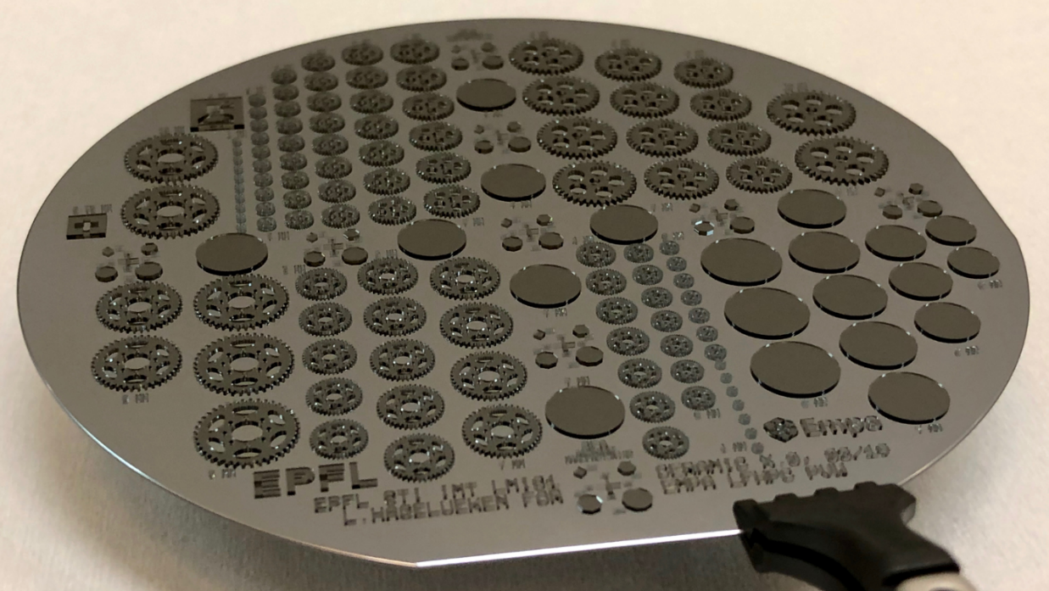

TITLE
Author
Semester/ Master project
Microsystems Laboratory, LMIS1

Lausanne, date

Assistants: |  | Professor:
Xx  yy |  | Name of Professor

Title
First name, Family name, Section Microtechnique
Assistant: Name(s)
Professor: Name

The Micro-Engineering section gathers the abstract pages of all the diploma projects.

This abstract page is included with the report on page 2. For semester projects, it is recommended that you also use the same template. .
.
.
Format Times 12

Légende obligatoire
Figures are very important. Use 1-2 in the abstract.
Attention à la lisibilité des figures et des caractères qui y figurent.
Faire le résumé en noir et blanc.
Vu que tous les résumés seront reliés et formeront un document, garder impérativement la forme de ce document
Le résumé doit tenir sur une page.

Légende obligatoire
Il est important de se rappeler que ce résumé formera la seule information disponible pour trouver un rapport de projet de diplôme ou de semestre. Tâchez donc d'y concentrer toutes les information utiles à ce but. Utilisez texte et dessins, mettez vous à la place de l'utilisateur.

Remember that this summary will be the only available information for finding a diploma or semester project report. Try to include all the information that is useful for this purpose. Use text and drawings, put yourself in the user’s shoes.

Beware of the legibility of figures and the characters in them.
The summary is in black and white.
Given that all abstracts will be combined into a single document, it is mandatory to keep the format of this document.
The abstract should fit on a single page.

(REM: Document Originale pour 2005, provenant du Secrétariat de la Section de Microtechnique).

Table of contents
The aims of a report 3
How to Structure a report 3
The basis 3
Realisation 4
Structuring your report 4
Summary with Project description 5
Table of contents 5
Introduction 5
Body of the report 5
Conclusions 5
Symbol list 6
Literature list 6
Appendices 6
The inside of a report 6
Page Layout 6
Headers and Footers 6
Using Styles 6
Chapters and contents 7
Numbering 7
Figures 8
Number presentation 10
Formulae 11
Tables 11
Updating Fields 12
Language aspects 12
Concise and simple sentences 12
Short words and active verbs 13
Bibliography 13
Appendix 1 14
Introduction
The purpose of this guide and template is to help you, the student, with writing good reports.
We emphasise that these are only guidelines. As a consequence these rules should be applied with intelligence. These guidelines are based on a manual of many years ago by teachers in Holland with additions from other sources and updated with input from a number of people at EPFL. For further reference, you may consult the recommendations by M. Whitesides¹ or the ANSI/NISO Norm Z39.18-1995.² Suggestions for improvements, from teachers and students, are always welcome.
The template includes some recommendations for your semester/master thesis project reports’ layout. The aim is to provide guidelines for a well readable report layout so that you can begin writing your report without loss of time for layout issues.

The aims of a report
The purpose of a report is to transmit coherent information on a subject to the target readers. Reports at the EPFL are usually technical and should be based on verifiable facts or experiments.
It is not a chronological description of your work.
Obviously, the requirements of your readers (and tutors especially) must be taken into account: what information is requested, how much does the reader know already, what interests him/her?
Write your report in such a way that your fellow students will be able to understand it and can put the contained information to use.
Semester and master reports may be part of a larger project. The success of the project may be influenced by the quality of the report. A clear and critical problem description and a well-motivated solution form an important contribution to the goal to be reached. A report is often the starting point for a next phase in the project. Therefore, a thorough description of the experiments and results are important, as well as clearly formulated conclusions.
Note: copying someone else’s work is not allowed! If you cite work/results from other sources, it is mandatory to cite them properly with a reference or footnote.

How to Structure a report

The basis
It starts with clear and complete notes that you take during your work. You should keep a well-organized notebook in which you put all information that relates to your project: study, notes, designs, discussion notes, measurements, calculations, failures, graphs etc.
During this time you should already work out and discuss some of your material for inclusion in your report, and plan on how you will present your work.

Realisation
There are many ways to do it, but what follows is, we think, a useful suggestion of how you can do it.
- First phase: inventory.
Write on a large piece of paper or in your word processor all main items that you must include in your report. Check the project description and your notes to see if you forgot something.
- Second phase: order and selection (see next).
Make a draft chapter division. Try to include all the main items in these chapters, and adapt them if needed. Order the chapters and items in a logical way. Do not hesitate to put at the beginning what you did at the end if it makes more sense.
- Third phase: write your report (see the next chapters for details).
- Fourth phase: checking
Read your report from start to end. You can also ask someone else to examine it and comment on it.

Structuring your report
Your report is meant to transmit relevant information, understanding and know-how that you developed during the project. Present it in a coherent, scientific way. In practice there is not much difference between semester and master reports. Typical layout:
- Title
- Summary (Project description for the section)
- Table of Contents
- Introduction
- Body of the report, with for example:
  - theory
  - design and motivation
  - design realisation
  - measurement set-up
  - results and discussion
- Conclusions
- List of symbols
- Literature list
- Appendices (may be put ahead of “Literature”)
Some clarifications:
Title
A title like “Silicon microfluidics” is insufficient. “Silicon microfluidic sensors” is better but lacks information on what has been done. Again better is for example “Fabrication and test of silicon microfluidic sensors”. And “Realisation and test of a novel microfluidic sensor” is more appealing.
On the title page belong as well:
- Name of writer
- Time period or date
- Institute where the work was done
- Names of professor, assistants

Summary with Project description
Here you give the description as formulated at the start. Inform the reader about the purpose, used methods and results; give the main conclusions and recommendations. Stress novelty and possible impact.

Table of contents
The chapters and sections (and if you like, subsections) are mentioned with their page number.

Introduction
Indicate in more detail the purpose, background, starting points and limitations. Explain briefly your approach and what is new. You can include acknowledgements to the persons involved in the project, or add Acknowledgements before the Introduction.

Body of the report
This will be split up in several chapters, depending on the work that has been done.
Nevertheless, the body should be logical and fluent. Transmit your message in the form of coherent information, which is not necessarily a historical description. In accord with the point of depart as formulated in the introduction, you should build up the subject matter in a logical way. All matter that you feel should be in the report but does not fit with that logic has to go to the appendix. Where appropriate you can refer to that in the text.
Examples of items in the body of the report:
- Theoretical background
- Reasons, motivations for design choices
- Key design or layout
- Simulations / calculations
- Key aspects of realisation
- Choice of measurement method or set-up
- Discussion of results

Conclusions
This is a very important part of a report. Give all relevant conclusions, even negative. Stress novelty and scientific or industrial impact. Also new insights, outlook and recommendations for improvement should be put here. However, do not introduce results or concepts that belong in the body of the report. Bring structure in your conclusions.

Symbol list
A report with a large number of symbols benefits from a symbol list. It should have all used symbols, preferably in alphabetic sequence (small letters, capital letters, Greek). Indicate both meaning and units. Try to adapt generally used symbols, and avoid the use of the same symbol for different meanings. Also non-standard abbreviations can be added here. Abbreviations are introduced ones at their first appearance and then used later on throughout the text.

Literature list
See section 5.6

Appendices
Hereunder fall items that would interrupt the fluidity of the body of the report, such as:
- Long derivations of formulas,
- Calculations that would interrupt the body of the report (keep them compact)
- Large tables with measurements or calculated results
- Large drawings and schemes or layouts, series of pictures
- Part lists and computer simulation print-outs (listings, runs)
The report must be understandable without the appendixes and contain all the important information.

The inside of a report

Page Layout
The page layout is based on the DIN A4 format. The side margins allow a good binding of the document on the left side. Normally semester project or master thesis reports are copied single-sided and glue-bounded. A larger margin on the ‘glue-bounded’ side of the page is therefore used. The margins in this template are for single-sided documents: Left 3.2 cm, Right 2 cm, Top and Bottom 2.5 cm. If you wish to use double-sided printing, remember to adjust the margins: on even-numbered pages (left pages), the left margin equals 2 cm and the right 2.7 cm. Odd-numbered pages (right pages) have a 2.7 cm left margin and a 2 cm right margin. You can control the difference in margin size, headers and footers between left and right pages in the Page Setup menu.

Headers and Footers
Edit the header and footers by either clicking on them or choosing from the Menu ‘View – Headers and Footers’. The three tab stops facilitate the alignment on the left, centre and right side.

Using Styles
A minimum number of styles were used for this template: Heading 1, Heading 2 and Heading 3, corresponding to three heading levels. Additionally Table of Contents Styles, Title, Caption and some more styles for the Abstract Page. You can change them with Format – Styles and Formatting.

Styles and Table of Contents
Using the heading styles allows to insert and update automatically the table of contents from the headings used. Update the table by right-click, then ‘Update Field’; Insert – Reference – Index and Tables – Table of Contents.

Inserting a Literature Reference
In this template, the endnote function is used for the references on articles. You can insert an endnote by choosing ‘Insert’ – ‘Reference’ – ‘Footnote’, then choosing the option ‘Endnote’, as for example done for the article on Magnetic Resonators by Olivier Martin [].

Chapters and contents
Start each chapter on a new page. Use large margins (ca. 3 cm left margin, top and bottom). Place pictures near the relevant text. Group the information in paragraphs.

Numbering

Chapters and sections
Preferably use a decimal enumeration system such as in this manual. The summary, appendices, literature list and symbol list are usually not numbered.

Formulas
Essential formulas and formulas that are referred to in other places in the report should be numbered.
For example:
(1)
If you do not have many formulas (say less than 20), you can use this type of numbering; otherwise you can use (3.1) etc., referring to the chapter that the formula is in.

Tables
Tables should be numbered, and indicated: Table 1, Table 2 (or Table 3.1, Table 3.2).

Figures
All graphics that are placed in-between the text, such as drawings, graphs, pictures are called “figure”. The figures are placed close to the related text. You can number them Figure1, Figure 2 etc. (or Fig.3.1, Fig.3.2).
Together with the numbering you include a clear figure caption that should be self-explaining: all the relevant information has to be in the figure and figure caption. State clearly what is shown: “Measured…”, “Simulated…”, “Theoretical…”, “Comparison…”,

Appendices
If you have many that can be grouped into types:
Graph A. First DC current measurement
Graph B. First AC current measurement
Mask 1. Back side
Mask 2. Front side
Mask 3. Metallisation
You indicate these in the Table of Contents as:
Graphs
Mask layouts

Figures
Indicate graphs, pictures and drawings with “Figure” or “Fig.”. Unfortunately, word does not allow different styles for different caption labels, but you can copy-paste the caption for other figures preserving in such a way the formatting.

Examples of a bad presentation (Fig.1) and good presentations (Fig.2 and Fig. 3):

Fig.1. First results | Fig.2. Measurement of evaporation rate as  function of input power (third order fit).
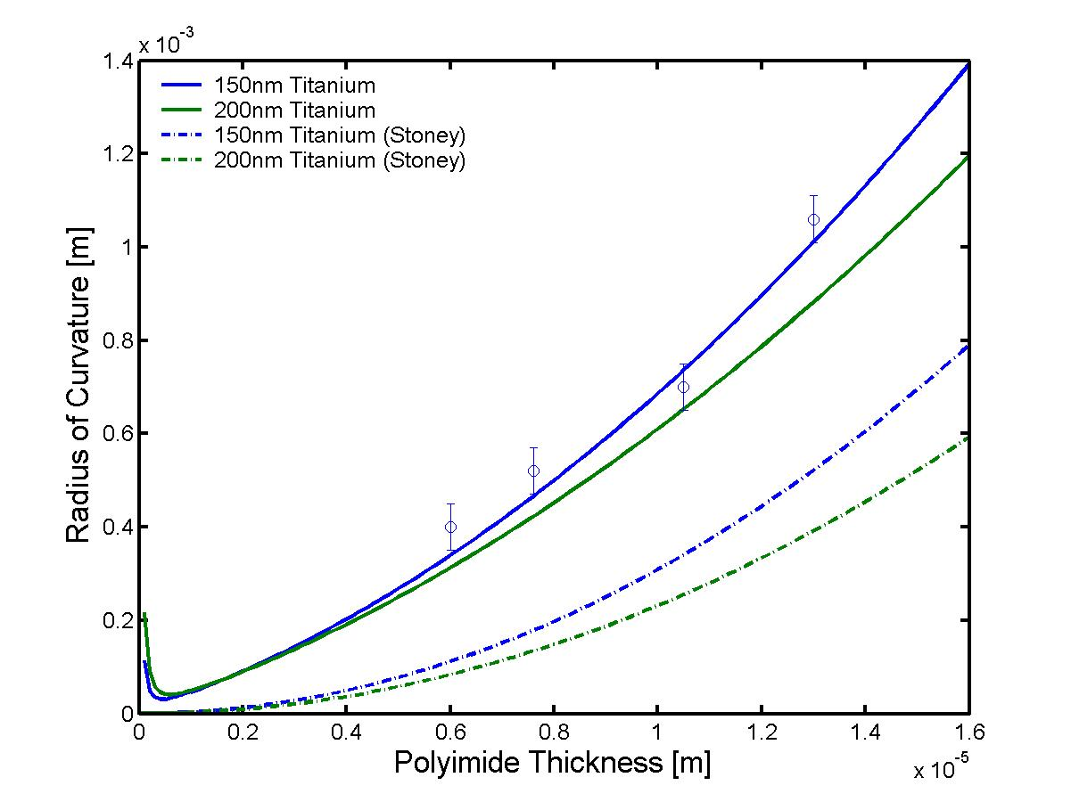
Figure 3 – Radius of curvature measured as a function of the polyimide thickness for bimorph structures using a polyimide PI2525 layer and a titanium layer. The measurements are represented as dots with their respective measurement incertitude. For comparison, the complete analytic formula is represented in solid lines and the approximate Stoney formula in dashed lines for a titanium thickness of 150 nm and 200 nm respectively.

Axes
- Horizontally (x) you put the independent variable (the cause) and vertically (y) the dependent variable (the result). For example, if you measure the resistance as function of the temperature: then you put the resistance on the vertical axis. But if you measure the temperature as function of a heater resistance, you put the temperature on the vertical axis.
- Divisions on the axes:
  - The space should be used efficiently.
  - Divide the axes in multiples of 1, 2, 5, 10 (etc.) units (“ticks”) in a readable way.
  - Consider the use of logarithmic divisions; realise what is useful and/or common.
  - Usually the axes go preferably through the origin (0,0).
  - Use exactly the same layout for two results that you want to compare (identical axes).
  - Near the axes you indicate the variable (preferably a symbol) and the units: e.g. I [mA] or t [s]. Describe what exactly is plotted as function of what.
  - If you don’t start at 0, it’s good to emphasize it (draw it yourself):
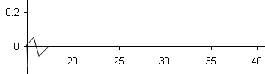

Measurement points
- Include all measurement points, also the ones that seem to be out of range. Make them sufficiently large to see them after you draw a line through them.
- Make sure when you do the measurements that the points will be well distributed. Where the graph behaves strangely (resonance peaks and so on) there should be more points (hopefully you realised that when doing the measurement!).
- It is useful to give an inaccuracy estimation with error bars (especially for large errors).

Lines
- Draw a smooth line without trying to exactly force them through all points, in accord with theory (expectation) and common sense (error bars are helpful for that). In some cases it is not beneficial to draw a line at all.
- Use different line styles, especially for lines that are close together or have a different meaning, such as theory and measurement (solid, dashed,..).
- If theory predicts that the points lie on a straight line, draw a straight line as good as possible through the points. If theory predicts the line to go through the origin, show the origin in the graph. It may be a good or a bad choice to force the line through the origin (comment on it in the text if you think there is an offset of some kind).

Number presentation
In general you should not give less, but also not more decimals than what is meaningful or useful. A calculator usually gives too many digits!
How many you should take into account or present depends on:
- The specifications of the equipment, either explicit (specifications) or implicit (number of digits, instability, time since last calibration)
- In calculations it is important how the inaccuracies influence the end value. It is wise to use at the start of calculations more digits than seem required or relevant, to prevent rounding errors. Watch out for dependence between errors: for example some systematic errors may have no effect on your result. Then one digit “too much” may be relevant after all!
Often an estimation of the accuracy (error) is useful. In further calculations you should not forget that you started with an estimation. In many cases a simple, so-called “worst-case” calculation will be sufficient. Such a calculation is valid for correlated or non-statistical errors. If applied to all errors, it easily results in overestimation (which can be acceptable). See Appendix 1 for a detailed discussion.
When you present values:
- Use prefixes (kV, mA, pF) or powers of 10: preferably multiples of 1000 (10⁻⁶, 10⁹ etc.).
- Indicate absolute errors in the same unit and power of 10.
- Be consistent with the number of relevant digits. Some examples:
4.0872 +/- 0.1 should be: 4.1 +/- 0.1
2.1 +/- 0.3 % should be: 2.100 +/- 0.3 % (or: 2.1 +/- 5 %)
0.845 +/- 1.728 % should be: 0.845 +/- 1.7 %

Formulae
If you would like to insert formulae in your report, don’t forget numbering them (Insert – Reference – Caption – Equation, check ‘exclude label from caption’ for formulae).
(1)
You can then refer to a formula such as Snell’s law (1) by inserting a cross reference, choosing the ‘Equation’ caption (Insert – Reference – Cross Reference – Equation).

Tables
The numbering for tables is done in an equivalent way with the ‘Table’ caption.

Property | PI2525 | PI2611
Tensile strength [MPa] | 131 | 350
Elastic Modulus [GPa] | 2.45 | 8.45
Stress (10 microns film) [MPa] | 37 | 0.2
Moisture uptake [%] | 2 - 3 | 0.5
Coefficient of thermal expansion[ppm/K] | 40 | 3
Glass transition temperature [°C] | > 320 | > 400
Decomposition temperature [°C] | 560 | 620
Table 1 – Properties of polyimides PI2525 and PI2611 (DuPont Datasheets)

- Put above or under the table a description (typically under, but above if the table is very long).
- Preferably make vertical tables which are easy to read (if causal: result in the right column!):
- In the headers above each column you mention:
  - The contents, often using a symbol (e.g. U).
  - The unit between brackets (e.g. [mV]); choose the unit to be convenient in size,
e.g. 13.6 mV instead of 0.0136 V (only use brackets [] where needed!).
  - The precision, if this is of importance and if similar for all values.
- Shift as much as possible information from the header to the description.
- Choose the sequence of columns in a logical way (put together what belongs together).
- Don’t put very long or wide tables in the text if not necessary. It is better for the reader if you put them in an appendix or split them up in smaller tables. Avoid that tables continue from one page to another.
Refer to the contents of a table, such as the polyimide properties (Table 1) in the text with a corresponding ‘Table’ caption reference.

Updating Fields
Before you print your report, make sure that all the fields (such as captions, page numbers, table of contents, etc.) are updated. You can easily update all together by selecting all text (ctrl-a), then start the updating macro (F9).

Language aspects

Concise and simple sentences
The writing style should be precise, clear and scientific. Long sentences are more difficult to understand than short ones and risk tiring your readers. Avoid unnecessary words.
You should have less than 20 words per sentence on the average; avoid more than 35 words in the longest sentence. Sentences like the former (separated by ; or : ) are counted as two.
Avoid too deeply nested sub-sentences. A horrific example:
“The differential equations, the solutions of which that must be solved with eight constants, to be derived from the boundary conditions, are known, have been derived”.
However, even short phrases can be difficult to understand. Try to avoid the so-called overstressed construction. Thus, instead of: “The lab equipment that we borrowed from the IOA turned out to be useless for our purpose.” Better write: “We borrowed lab equipment from the IOA, but it was useless for our purpose. ”
Also, be to the point: keep unnecessary words and repetitions to a minimum. Not: “By slow and careful evaporation of water we perform the needed dehydration until it is dry.” Better: “We dry it slowly.”

Short words and active verbs
Sentences can be tiring because of too many long words. If you spot such, try to replace some words by shorter synonyms.
Scientific articles and scientific books are usually written in an impersonal style as this gives a modest and “objective” (neutral) impression. It is common practice not to use “I”, and rarely “we”. Sentences tend to use the passive form as a result.
For example it is common to read “The influence of a higher viscosity on the layer thickness was investigated”. However, now it is not clear if the author did it, someone else, or another group! To convey the same information it should be “The influence of a higher viscosity on the layer thickness was investigated by the author”, which is a bit heavy.
A trick some people use is: “The author investigated the influence of a higher viscosity on the layer thickness”. In lab reports you can be more personal and simply write “I” or “we”.
Often a sentence can be changed from the passive form to the active form by rearranging the words. Instead of “The pull strength was doubled by the addition of 3.6% wolfram”, you can simply write: “Adding 3.6% wolfram doubled the pull strength”.

Also, instead of: “Water condensation is likely to occur in the narrow gap” it is better to write: “Water may easily condensate in the narrow gap.”

Bibliography
1. Whitesides, G. M. Whitesides’ Group: Writing a Paper. Adv. Mater. 16, 1375–1377 (2004).
2. National Information Standards Organization [NISO]. ANSI/NISO Z39.18-1995 - Scientific and Technical Reports - Elements, Organization and Design (revision and redesignation of ANSI Z39.18-1987). (1987).

Appendix 1
SIMPLE APPLICATION OF STATISTICS TO MEASUREMENTS

Sample standard deviation estimation:

S_{(N-1)} =
Standard deviation of the sample mean:

S_{mean} = Statistical error decreases with √N.

65% and 95% confidence interval

The estimated error E_{x} is usually taken as twice (2x) the sample standard deviation S, corresponding to 95% confidence interval (only valid for a large number of samples ^{[3]}).
However in reports about measurements often +/- 1 standard deviation is indicated, corresponding with ca. 65% confidence interval for a large number of samples.
Which ever you choose, you should make clear which confidence interval is implied.

Addition and subtraction of error estimations

For multiple independent errors you can simply add the uncertainties if they are small; however that is overly pessimistic. Some rules for worst-case calculations:

- Additions and subtractions: add absolute errors
- Multiplications and divisions: add relative errors (%)
- Square root: half the error
- If you don’t know or are not sure, calculate the extremes (sin x, ln x etc.)
If you have large independent estimated errors of a statistical nature, you should sum the squares of the errors, in accordance with standard deviation theory.
Thus: with E_{x}= error.

As above, work with absolute errors for additions, and relative errors for multiplications.

Further reading:

[1] http://davidmlane.com/hyperstat/A16252.html
[2]http://en.wikipedia.org/wiki/Standard_deviation#Relationship_between_standard_deviation_and_mean
[3] For 3 or 4 samples you should take not 2S but 3S for 95% confidence. See:
http://en.wikipedia.org/wiki/Student%27s_t-distribution
[4]http://www.cartage.org.lb/en/themes/sciences/chemistry/miscellenous/helpfile/Erroranalysis/AdditionSubtraction/AdditionSubtraction.htm

