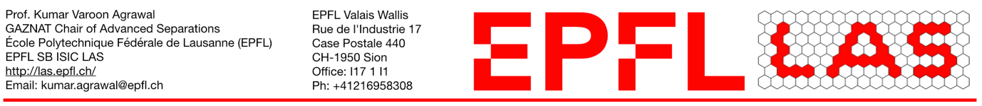
Postdoctoral Research Associate Position
Applications are invited for a postdoctoral researcher position at École Polytechnique Fédérale de Lausanne (EPFL) working with Prof. Kumar Varoon Agrawal for the development of membranes for molecular separations using two-dimensional materials.

Background:
We are looking to develop the separation science using two-dimensional materials, in particular porous graphene film. Porous graphene is prepared by controlled oxidation. The current project seeks to develop chemistry and material engineering approaches to achieve the potential of two-dimensional materials. We are looking for a postdoctoral candidate with strong experience in chemistry/engineering of two-dimensional materials. Experience with membranes is a must.

Qualifications:
- The candidates should have recently obtained a PhD in chemical engineering/ /chemistry/material science.
- The candidate should have prior experience in membrane-based research.
- The candidate must be proficient in written and spoken English.
- The candidate must work proficiently in a multidisciplinary, diverse, and international team consisting of chemists, chemical engineers, and material scientists.

Additional information:
The initial contract will be for a period of one year extendible up to four years. The salary will be according to the scale for a postdoctoral candidate at the ETH board in Switzerland.

Application procedure:
Send an email to kumar.agrawal@epfl.ch with a cover letter and CV which should include a detailed educational background, publication record, awards, presentations, and references. The subject of email should be postdoctoral_position@2DMembrane

