Soft Multi-Modal Biosensing Patch for Continuous Physiological Vitals Monitoring

(Master project with Industry)

Contacts: Lavinia Alberi (laviniaa@vitalizedx.com );

Sandro Carrara (sandro.carrara@epfl.ch )

Abstract
This Master thesis aims to design, fabricate, and validate a wearable soft biosensing patch for continuous physiological monitoring at the retro-auricular (behind-the-ear lobe) site. The device will integrate flexible electrodes and sensors to simultaneously measure heart rate (ECG), breathing rate (impedance pneumography), skin temperature, and sweat biomarkers. By leveraging advanced hydrogel and PDMS-based conductive materials, the project seeks to develop a comfortable, long-term monitoring platform that combines multiple sensing modalities within a single flexible patch.
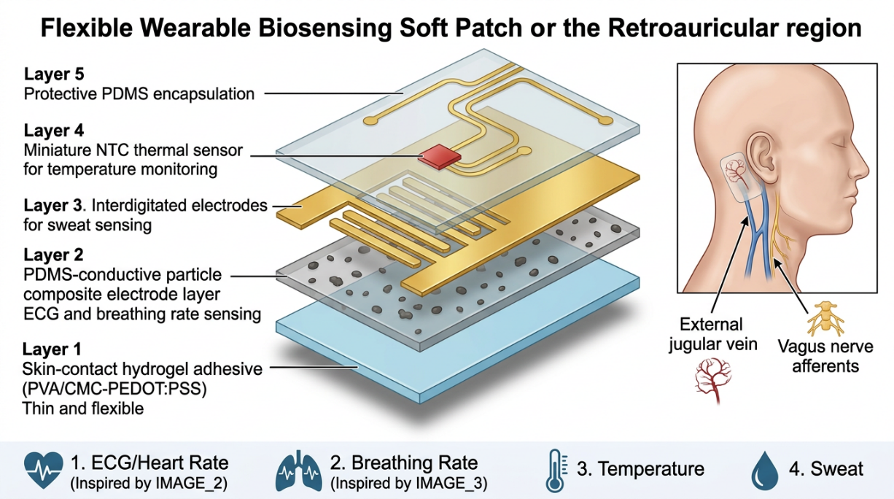
Conducted at the Integrated Systems Laboratory (LSI) at EPFL under the supervision of Prof. Sandro Carrara in collaboration with the Health Sportech Startup VitalizeDx, the work will focus on material optimization, sensor integration, signal processing, and validation against clinical reference devices. The resulting prototype will address the growing need for unobtrusive wearable health technologies with applications in remote patient monitoring, sports medicine, and personalized healthcare.

Background and Motivation
Commercial wearable systems such as Zio XT, Vivalink, and Resmetrix have demonstrated the clinical value of continuous physiological monitoring, but most are limited to one or two sensing modalities. The retroauricular region offers an attractive alternative location due to its proximity to vascular and neural structures, stable skin topology, low motion artifacts, and discreet wearability. Recent advances in stretchable hydrogels, conductive composites, and epidermal sensors enable the development of highly conformable devices capable of multi-parameter monitoring.

Objectives
The project aims to develop a soft wearable patch capable of continuous monitoring of:
- Heart rate through ECG.
- Breathing rate through impedance pneumography.
- Skin temperature.
- Sweat biomarkers (e.g., pH, glucose, or electrolytes).
Additional objectives include optimizing electrode performance, integrating multiple sensing modalities on a flexible substrate, validating measurements against gold-standard instruments, and assessing long-term wearability and biocompatibility.

Methodology
The work will be organized into four phases:
- Material Development: Fabrication and characterization of conductive hydrogel and PDMS-composite electrodes, assessment of conductivity, stretchability, adhesion, and skin compatibility.
- Device Integration: Design and fabrication of a flexible multi-layer patch integrating ECG, respiratory, thermal, and sweat sensing components with wireless communication capabilities.
- Validation: Bench-top and pilot human studies comparing device outputs with commercial ECG systems, respiratory monitors, thermometers, and laboratory sweat analyses.
- Data Analysis: Development of signal-processing algorithms and statistical evaluation of measurement accuracy and reliability.

Expected Outcomes
The thesis is expected to deliver:
- A functional behind-the-ear multi-modal biosensing patch.
- Characterization data for flexible electrode materials.
- Demonstration of accurate monitoring of cardiovascular, respiratory, thermal, and biochemical parameters.
- Validation of long-term wearability and user comfort.
- A foundation for future clinical translation and commercialization of unobtrusive wearable monitoring systems.

Impact
By combining multiple sensing technologies into a single soft wearable platform optimized for the retro-auricular site, this project will advance the field of wearable bioelectronics and contribute to next-generation solutions for remote healthcare, preventive medicine, and performance monitoring.
References:
- Nan Zhang et al., Polymer Testing 158 (2026) https://doi.org/10.1016/j.polymertesting.2026.109184
- Uyanga KA, Onyeukwu EJ, Han J. Advancing Wearable Technologies with Hydrogels: Innovations and Future Perspectives. Gels, MDPI, 2025 Dec 8;11(12):988. doi: 10.3390/gels11120988. PMID: 41441144; PMCID: PMC12732722: https://www.mdpi.com/2310-2861/11/12/988
- Sharma, Pragya, et al. "Wearable radio-frequency sensing of respiratory rate, respiratory volume, and heart rate." NPJ digital medicine 3.1 (2020): 98. https://www.nature.com/articles/s41746-020-0307-6

