Master Thesis/Semester Project

CMOS design for vision restoring by cortex stimulation
Contacts Hamid Sadat Mansoury (seyyed.sadatmansoury@epfl.ch)
Professors Sandro Carrara (sandro.carrara@epfl.ch)

Introduction
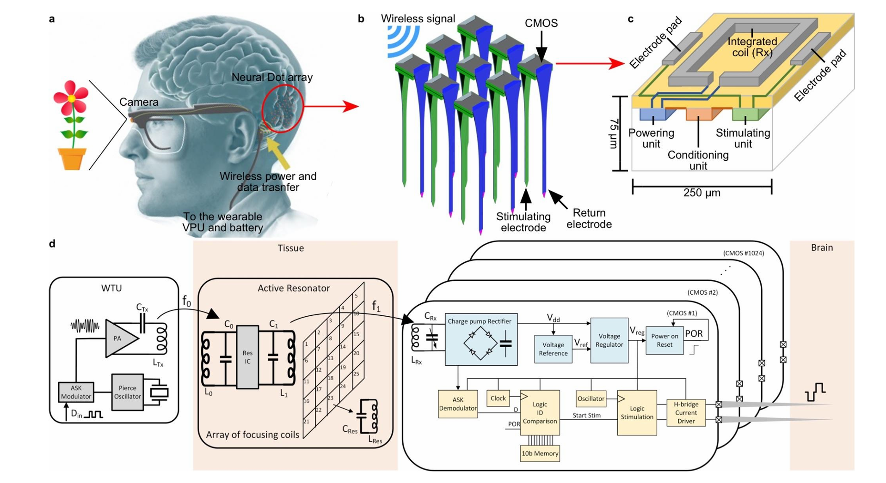
Figure 1: a) System overview. b) Sketch of a 3 x 3 Neural Dots array. The wireless signal (power and data) is sent to the array and the selected Dots are triggered for focalized micro stimulation of the visual cortex. The pink tips are the stimulating electrodes (2 per dots). c) Symbolic Sketch of the CMOS chip (not in scale). d) System block diagram. Left: WTU transmitting power and data at f₀. Middle: active resonator composed of an IC connected to two concentric coils and an array of small focusing coils to relay power and data at f₁. Right: single Neural Dot, out of the 1024 powered by the resonator, including analogue (blue) and digital (yellow) circuits to deliver biphasic current pulses.

Wireless, miniaturized, and distributed Brain-Machine Interfaces (BMIs) are the essential building blocks for the next generation of Cortical Visual Prostheses. To restore functional artificial vision, thousands of stimulating sites are required to provide sufficient resolution for the user. While early implants were limited to only a few dozen channels, recent advancements in Wireless Power Transfer have enabled scaling up to several hundreds. By leveraging highly distributed architectures, we can now envision a one-to-one correlation between visual field pixels and thousands of independent miniaturized neurostimulators [1].
As illustrated in Figure 1-b, the system consists of "NeuralDots" integrated with 3D micro-electrodes [2]. Each dot contains a CMOS circuit (detailed in Figure 1-d) that handles power management and neural stimulation. Given the level of integration required, an inductive link is chosen for WPT due to its high manufacturability, repeatability, hermeticity, and mechanical stability.
The primary drawback of 2-coil inductive links is their low efficiency and high sensitivity to misalignment. Since each NeuralDot has a footprint of approximately 300µm×300µm, the receiver coil is no longer millimeter-scale. At this sub-millimeter scale, the efficiency of the inductive link becomes a critical bottleneck for the entire system's performance and power budget.

April 2026

Project Description

This project focuses on investigating and optimizing the wireless power link for ultra-miniaturized cortical implants. The student will follow these stages:

- Literature Review: Comprehensive study of methods to enhance inductive link efficiency, including 3-coil passive/active links [3,4] and electromagnetic lenses (EM-Lens) [5].

- EM Simulation: Modeling the tissue environment and simulating various WPT architectures in ANSYS HFSS to compare their effectiveness and robustness.

- Design & Optimization: After selecting the most effective method, the student will design:

  - The On-chip receiver coil in CMOS technology.
  - The Intermediate resonator (or EM-Lens).
  - The External transmitter coil.

- Prototyping & Measurement: Fabricating the proposed coils and performing experimental measurements to validate the simulated PTE.

Student Learning Goals
By joining this project, you will gain:
- Hands-on experience in analog/RF circuit design using TSMC 180nm technology within the Cadence Virtuoso environment.
- Practical skills in electromagnetic modeling and simulation using industry-standard tools like Ansys HFSS and EMX.
- pecialized knowledge in designing Wireless Power Transfer systems tailored for high-density, implantable medical devices.
- Understanding how to develop and optimize high-efficiency rectifiers and coils under extreme area limitations (sub-mm footprint).
- Opportunity to verify your theoretical simulations with practical, real-world measurements in the lab.
- The ability to evaluate and optimize different WPT architectures (e.g., EM-Lens vs. Multi-coil links) to improve efficiency and reduce misalignment sensitivity.

Requirements
- Solid Foundation in Electromagnetic Theory and Wave Propagation.
- Fundamental Understanding of CMOS device physics and analog circuit operation.
- Strong Interest in electromagnetic modeling and simulation using Ansys HFSS and EMX.
- High Motivation for conducting hands-on EM experiments and lab measurements.
- Prior Experience (or academic coursework) in near-field Wireless Power Transfer (WPT) or inductive link design is a plus.

Project Duration
The project objectives can be tailored according to the duration of your involvement (e.g., semester project or master’s thesis); however, a minimum duration of six months is required.

[1]: G. L. Barbruni, F. Rodino, P. M. Ros, D. Demarchi, D. Ghezzi and S. Carrara, "A Wearable Real-Time System for Simultaneous Wireless Power and Data Transmission to Cortical Visual Prosthesis," in IEEE Transactions on Biomedical Circuits and Systems, vol. 18, no. 3, pp. 580-591, June 2024, doi: 10.1109/TBCAS.2024.3357626.

[2]: J. Qian et al., "Miniaturized Foldable Electrodes with Direct CMOS Integration for Implantable Applications," 2025 IEEE Biomedical Circuits and Systems Conference (BioCAS), Abu Dhabi, United Arab Emirates, 2025, pp. 359-363, doi: 10.1109/BioCAS67066.2025.00084.

[3]: M. Kiani, U. -M. Jow and M. Ghovanloo, "Design and Optimization of a 3-Coil Inductive Link for Efficient Wireless Power Transmission," in IEEE Transactions on Biomedical Circuits and Systems, vol. 5, no. 6, pp. 579-591, Dec. 2011, doi: 10.1109/TBCAS.2011.2158431.

[4]: G. L. Barbruni, C. Cordara, M. Carminati, S. Carrara and D. Ghezzi, "A Frequency-Switching Inductive Power Transfer System for Wireless, Miniaturised and Large-Scale Neural Interfaces," in IEEE Transactions on Biomedical Circuits and Systems, vol. 18, no. 3, pp. 679-690, June 2024, doi: 10.1109/TBCAS.2024.3359481.

[5]: J. Ge, B. Ozbek, P. Feng, A. Mifsud and T. G. Constandinou, "Flexible Electromagnetic-Lens for Wireless, Implantable Brain Machine Interfaces," 2024 IEEE Biomedical Circuits and Systems Conference (BioCAS), Xi'an, China, 2024, pp. 1-5, doi: 10.1109/BioCAS61083.2024.10798285.

