Master Thesis/Semester Project Junyan Qian (junyan.qian@epfl.ch), Roberta Grasso (roberta.grasso@epfl.ch)

Next-Generation Silicon Nanowire Biosensor for Cancer Marker Detection
Contacts Junyan Qian (junyan.qian@epfl.ch), Roberta Grasso (roberta.grasso@epfl.ch)
Professor Sandro Carrara (sandro.carrara@epfl.ch)

Introduction
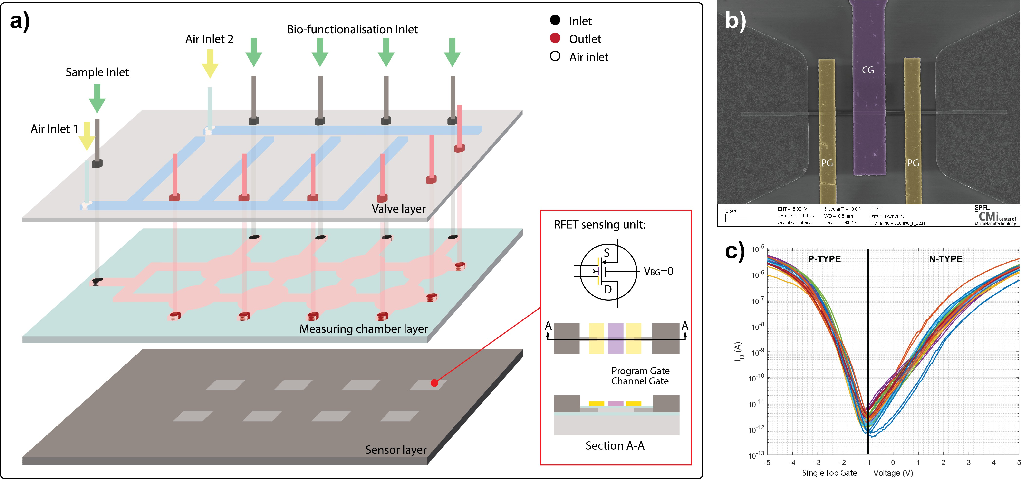

Figure 1: a) Microfluidic implemented system. b) The SEM image of the RFET. c) The transfer function of a single top gate RFET, the current is in logarithmic scale.

Biosensors based on nanomaterials, particularly silicon nanowires (SiNWs), have demonstrated exceptional po-tential for ultrasensitive biomolecular detection. Their nanoscale dimensions, comparable to those of biological molecules, enable highly efficient interactions with target analytes. Moreover, the atomically thin active layers of SiNWs provide an outstanding surface-to-volume ratio, which greatly enhances charge sensitivity, signal trans-duction efficiency, and detection speed. As field-effect transistor (FET)-based devices, SiNW sensors rely on modulation of channel conductivity through changes in gate potential. Since biomolecules are inherently charged, their binding to receptors immobilized on the SiNW surface alters the local electric field, thus affecting the device’s conductance. Leveraging this mechanism, SiNW-FETs have achieved detection limits down to the attomolar range for a variety of analytes, including DNA, RNA, proteins, and viruses.
Despite these advances, a major challenge remains: enabling the simultaneous detection of multiple targets on a single platform. Multi-target sensing is particularly crucial for elucidating complex biological systems, especially in oncology, where both the absolute concentration and relative ratios of biomarkers provide essential diagnostic and prognostic insights into tumor type, metastatic progression, and disease severity. Indeed, numerous studies have demonstrated that the combined detection of multiple biomarkers significantly improves the accuracy and sensitiv-ity of early cancer diagnosis. To address the limitation of SiNW-FETs in detecting multiple targets, a promising alternative is the Reconfigurable Field-Effect Transistor (RFET) based on silicon nanowires. Unlike traditional FETs, RFETs are not doped during fabrication. Instead, they use electrostatic doping, meaning that the type of charge carriers (electrons or holes) is defined by voltages applied to multiple gates rather than by fixed chemical doping. As a result, the same device can switch between n-type and p-type operation simply by changing the applied gate voltages.

This unique property offers several important advantages for biosensing:

November 2025

- Versatility: the same device can detect both positively and negatively charged molecules, making it useful for a wide range of analytes.
- Better control: having multiple gates allows more precise adjustment of the device performance, improving sensitivity and response.
- Flexible circuit design: because the polarity can change dynamically, RFETs make it easier to build innovative circuit architectures.
- Multi-target detection: the presence of several gates provides more areas for functionalization, allowing the detection of multiple biomolecules on one chip.
- Lower Debye length: the undoped channel region intrinsically has lower charge accumulation. This leads to a lower Debye length in physiological sample, which is one of the major signal suppression for Nanowire FET sensor.

Project Description
The project focuses on the fabrication, characterization, and microfluidic integration of a reconfigurable field-effect transistor (RFET) biosensor for Colorectal Cancer (CRC) detection.
Fabrication and microfluidic integration will be carried out in the EPFL Cleanroom facilities (CMi), while charac-terization will include both structural analysis (SEM, AFM, optical microscopy) and electrical measurements.

Depending on your interests, it is possible to focus either on the fabrication and electrical characterization of the RFET device, or on the microfluidic design and integration aspects.

Student Learning Goals
By joining this project, you will gain:
- Hands-on experience in nanofabrication techniques within cleanroom facilities.
- Practical skills in advanced imaging methods such as SEM and AFM.
- Experience in electrical characterization of nanoscale transistor devices.
- Understanding of how to develop and optimize a successful microfluidic platform for biosensing applications.
- Insight into the physical phenomena at the nanoscale that affect device performance.
- The ability to critically analyze and optimize device behavior for sensing applications.

Requirements
- Basic knowledge of microfabrication processes.
- Basic understanding of the physics of CMOS devices.
- Interest in either nanofabrication or microfluidic system design.
- High motivation and determination to perform scientific experiments.
- Prior experience in the EPFL Cleanroom facilities (CMi) or in microfluidic device handling is a plus.

Project Duration
The project objectives can be tailored according to the duration of your involvement (e.g., semester project or master’s thesis); however, a minimum duration of four months is required.

2

