Master Project Call
Oscillatory Neuristor Based on SiNW Unipolar Memristor: Circuit Design & ODE Modeling
Background:
Memristive devices provide history-dependent I–V behavior suited for neuromorphic computation. Si nanowire (SiNW) unipolar memristors combine CMOS-friendly fabrication with compact switching, making them attractive for oscillatory neuron primitives (“neuristors”). This project targets a self-sustained oscillatory neuristor that demonstrates controllable spiking/oscillation using a real SiNW unipolar device, plus a compact ODE model aligned with the device’s internal state dynamics. Delivering a consistent bridge between bench measurements, SPICE/Verilog-A, and ODE simulations is the key gap we aim to close.
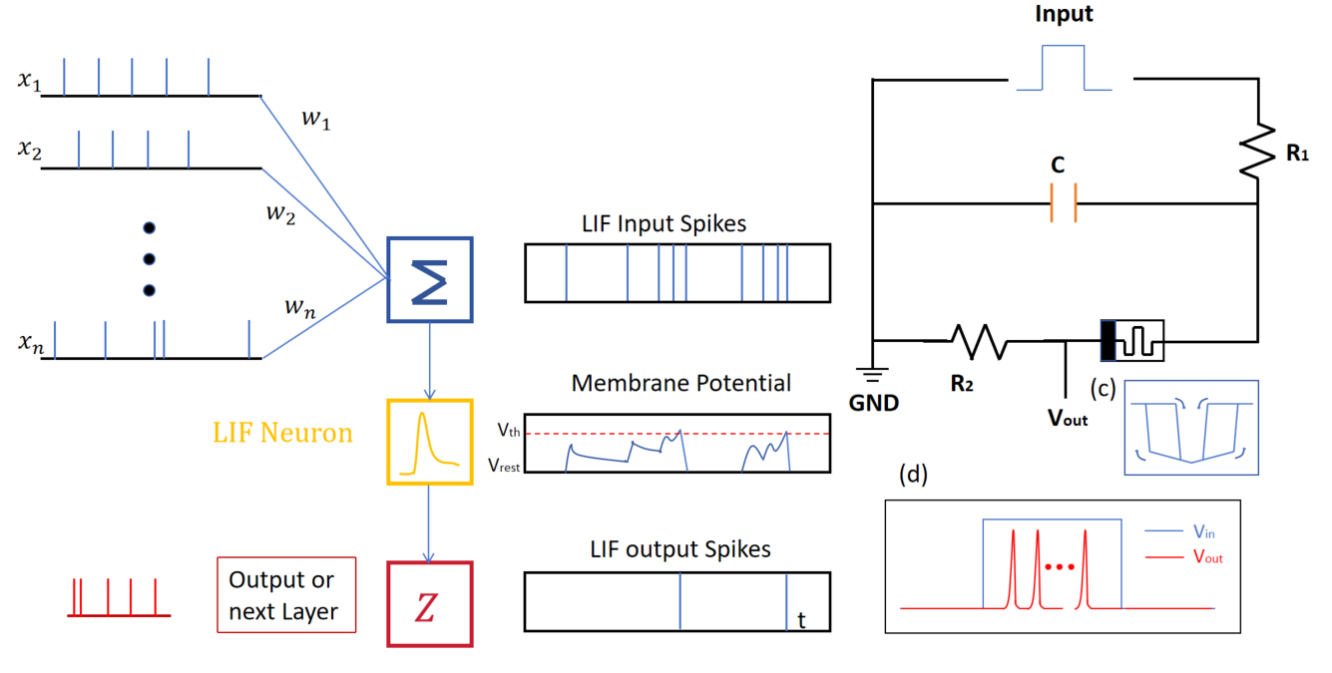

Objectives
O1–Circuit: Design and realize a self-oscillating neuristor using a SiNW unipolar memristor; achieve tunable oscillation.
O2–Modeling: Develop a low-order ODE model, by introducing negative differential resistance (NDR) to avoid dead region problem.
O3 - Consistency: Align ODE, SPICE/Verilog-A, and bench results on frequency, duty cycle, start-up time, and basic jitter; provide ≥3 matched case studies.
O4 - Demo (optional): Show frequency coding or phase locking with two coupled neuristors.

Methods, Tools & Equipment
Hardware: SiNW unipolar memristor samples/structures; SMU/parameter analyzer.
EDA & Modeling: LTspice/NGspice/Cadence Spectre; Verilog-A; MATLAB/Simulink or Python (NumPy/SciPy); version control with Git.
Analysis: Parameter fitting, sensitivity/uncertainty, robustness curves.
Milestone

Milestone | M1 | M2 | M3 | M4 | M5 | M6
Literature & plan
ODE derivation & parameter fit
First circuit + SPICE baseline
Cross-validation (ODE/SPICE)
Coupling demo
Final report

