Optimization of Schottky Barrier Formation for Reconfigurable Field Effect Transistors (RFETs)
Contacts: Junyan Qian (junyan.qian@epfl.ch)
Sandro Carrara (sandro.carrara@epfl.ch)
4
1
2
3
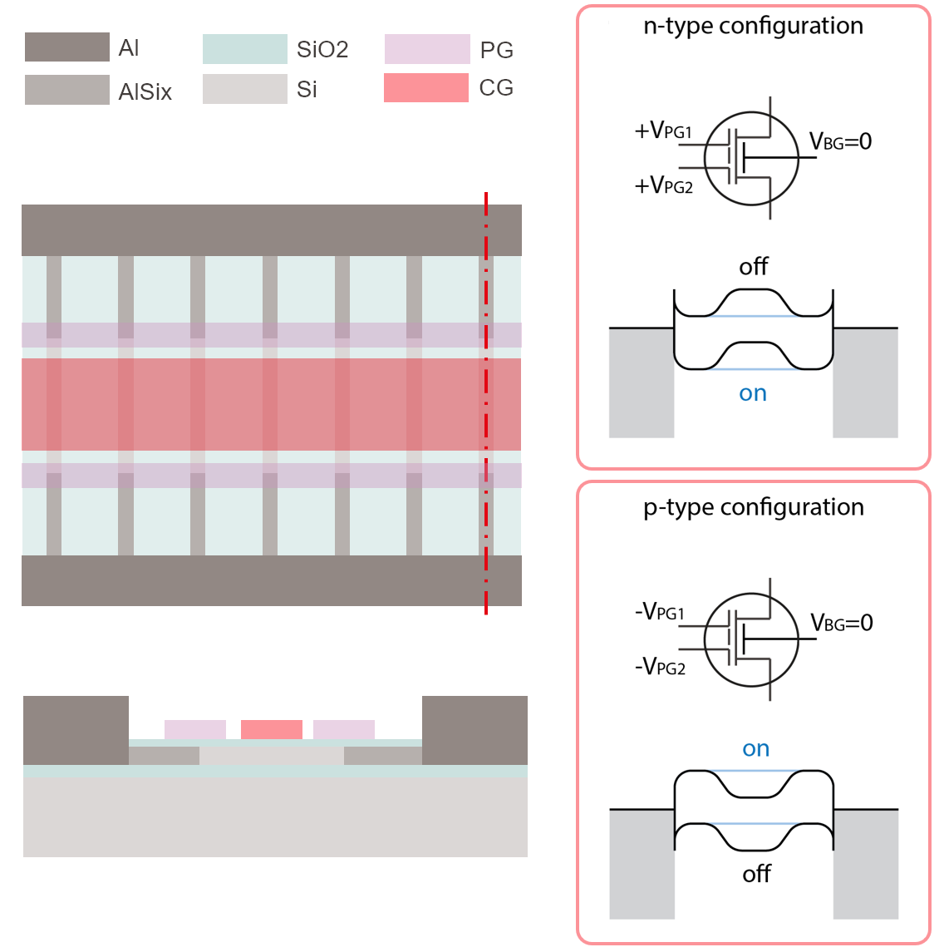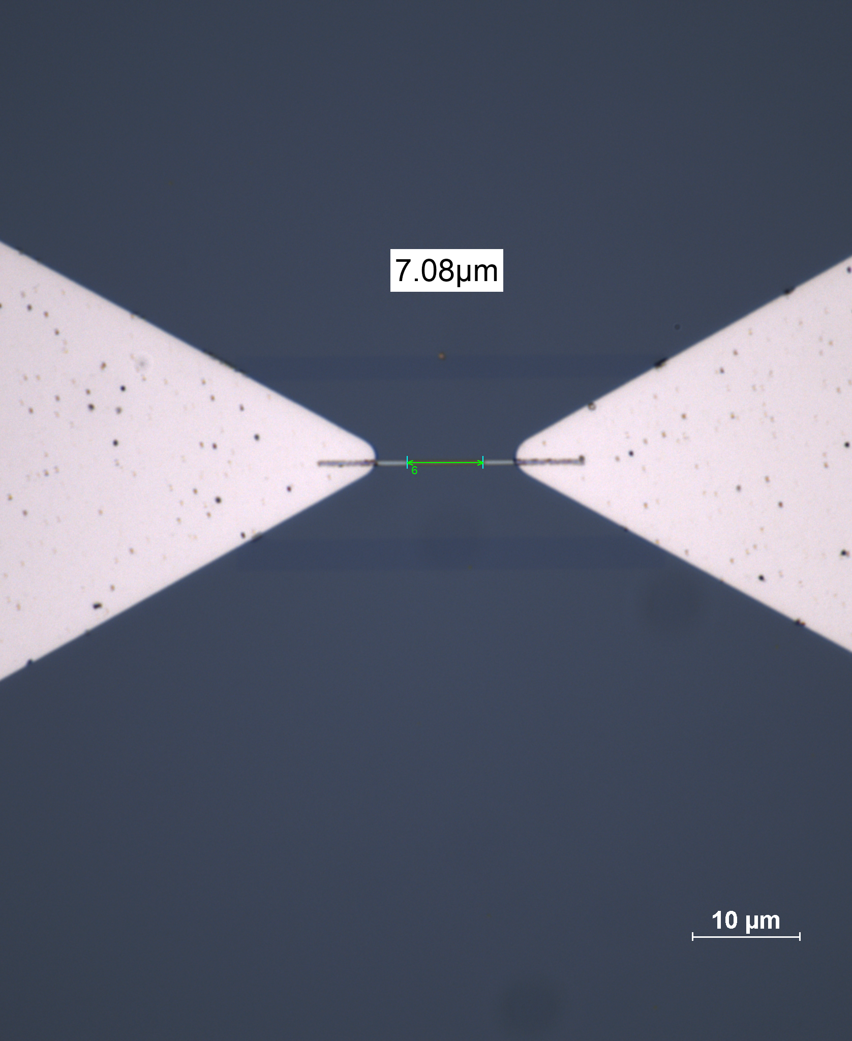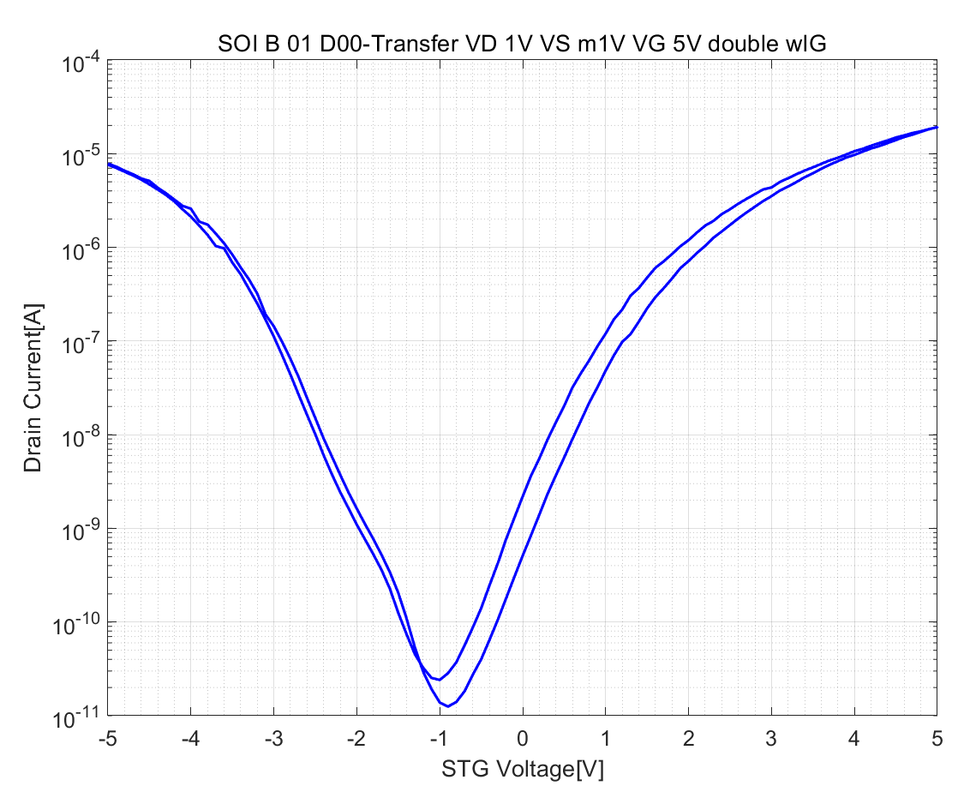
Figure 1. Top and side views of the RFET with multiple channels; Figure 2. (a) The working principle of n-type FET, PG is positively biased; (b) The working principle of p-type FET, PG is negatively biased; Figure 3. The length of the Si nanowire channel after annealing; Figure 4. The typical single top gate(short circuiting PG and CG) mesurement of RFET.
Introduction:
With the end of Moore’s law approaching, traditional scaling of CMOS technology faces physical and economic limitations. A promising alternative lies in Reconfigurable Field Effect Transistors (RFETs), which can dynamically switch between n-type and p-type operation within the same device. This capability enables adaptive integrated circuits with improved energy efficiency, reduced footprint, and novel logic architectures.
As shown in Figure 1, the RFET is typically based on a silicon nanowire channel with two unique gates: a program gate (PG) controlling the injection of carriers through Schottky barriers, and a control gate (CG) regulating channel conduction. The ability to reconfigure carrier type (electrons or holes) depends critically on the quality and stability of the Schottky contacts formed between metal and silicon. Its working principle is illustrated in Figure 2, the charge carriers are injected via tunneling effect. The Schottky barrier is formed by annealing the metal at certain temperature, the metal will diffuse into the Si nanowire as shown in Figure 3.
However, Schottky barrier formation is sensitive to annealing conditions. Inappropriate thermal treatment can cause undesirable granulation of the metal, leading to voids or cavities within the nanowire and ultimately device failure. Optimizing annealing parameters (temperature, ramp rate, duration, and atmosphere) for different metal/silicon interfaces is therefore essential to achieve reliable RFETs.
Project Objectives:
- Fabricate Schottky barriers in silicon nanostructures using different metals and annealing methods.
- Systematically study the effect of annealing parameters (temperature profile, duration, heating method) on interface quality.
- Characterize the structural properties of the resulting Schottky contacts using SEM and TEM (if available).
- Assess the electrical performance of the fabricated RFETs using a semiconductor parameter analyzer, a typical result is shown in Figure 4.
- Derive guidelines for optimal annealing conditions to ensure robust Schottky barrier formation without device degradation.
Methodology:
- Fabrication: Use CMi facilities to deposit selected metals (e.g., Ni, Al) on Si nanowires and form Schottky contacts.
- Annealing Study: Perform annealing under different temperature profiles (rapid thermal annealing vs. furnace annealing).
- Characterization: Structural: SEM (morphology, void detection), possibly TEM or AFM for higher resolution.
- Electrical: I–V characterization, barrier height extraction, transistor reconfigurability tests.
- Analysis: Correlate structural properties with electronic performance to identify optimal process parameters.
Student Learning Goals:
- Acquire hands-on experience with nanofabrication techniques (lithography, metal deposition, annealing and etc.).
- Develop skills in device characterization using SEM and semiconductor analyzers.
- Gain understanding of metal-semiconductor interfaces and their role in advanced transistor design.
- Apply critical thinking to optimize process parameters for nanoscale device fabrication.
Project Duration:
One semester (approx. 4–5 months).
Requirements:
- Basic knowledge of microfabrication
- Basic knowledge of the physics of CMOS devices.
- Experience in EPFL cleanroom facilities (CMi) is a plus.
- High motivation and determination to carry out scientific experiments.
Kick-start Reading list:
[1] For general RFET concept: A. Heinzig, S. Slesazeck, F. Kreupl, T. Mikolajick, and W. M. Weber, “Reconfigurable Silicon Nanowire Transistors,” Nano Lett., vol. 12, no. 1, pp. 119–124, Jan. 2012, doi: 10.1021/nl203094h.
[2] For Al-Si formation: L. Wind et al., “Monolithic and Single-Crystalline Aluminum–Silicon Heterostructures,” ACS Appl. Mater. Interfaces, vol. 14, no. 22, pp. 26238–26244, Jun. 2022, doi: 10.1021/acsami.2c04599.
[3] For Al-Ni formation: W. M. Weber et al., “Silicon-Nanowire Transistors with Intruded Nickel-Silicide Contacts,” Nano Lett., vol. 6, no. 12, pp. 2660–2666, Dec. 2006, doi: 10.1021/nl0613858.

