in-Memory Sensing
**** Master Project ****
Contacts: Sandro Carrara

Von Neumann computational provided to humanity an enormous advantage allowing spreading of computational power all around the world, nowadays largely embedded in personal electronics too. However, new applications, e.g. in the field of Artificial Intelligence, require now more and more computational power, including faster operations. While moving data from memory to processing units is “time consuming”, and then represents one of the bottlenecks in computation.

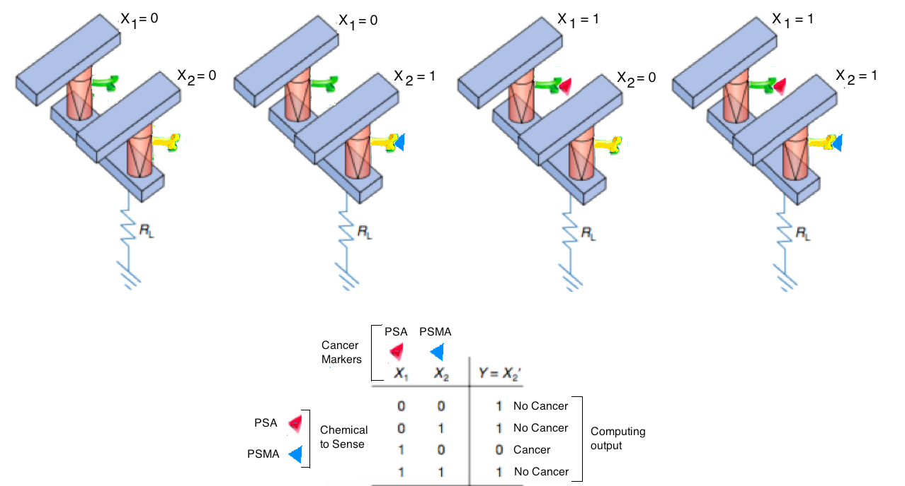
Project Description:
In this context, aim of this master-project work is to design, and demonstrate a very-first ever-proposed simple-architecture enabling the further new concept of “in-memory sensing”. This new proposed machine will automatically provide even more than the present edge-computing since, here, the computing will be done in the sensors, not close to the sensor. This is a completely new concept that introduces the novel idea of an “in-memory sensing”, with capability to sense, simultaneously compute, and, of course, memorize data in the very same device at the very same instant-of-time.
Eligibility Requirements:
- Basic knowledge on sensors
- Basic knowledge of electronics
- Basic knowledge of simulations/modelling systems (e.g., MatLab, C-programming)
- Interest, Motivation, and Commitment to the project
References:
- D. Ielmini, and H.-S. P. Wong, “In-memory computing with resistive switching devices,” Nature Electronics, 1(2018), pp. 333-343: https://www.nature.com/articles/s41928-018-0092-2
- Tzouvadaki, I., Puppo, F., Doucey, M. A., De Micheli, G., Carrara, S.. Computational study on the electrical behavior of silicon nanowire memristive biosensors. IEEE Sensors Journal, 15(2015) 6208-6217: https://ieeexplore.ieee.org/abstract/document/7156059

