New solutions for 3D microelectrode integration in ultra-miniaturised neural implant
**** Master Project ****
Contacts: Sandro Carrara
Gian Luca Barbruni

Implantable neural interface devices are an emerging technology for continuous brain monitoring, brain-computer interface (BCI) and neurostimulators. Recent advances in semiconductor and nano-, micro-technology has enabled the miniaturization of such devices even to the sub-millimetric scale. Failure point of the system is the connection between the CMOS and the proper microelectrode. Nowadays, microelectrodes are usually manually attached to the CMOS-pads. This method has several disadvantages, such as low reliability and repeatability, low scalability toward miniaturised implants and it is limited to the use of conductive silver paste, which has poor electrical properties.
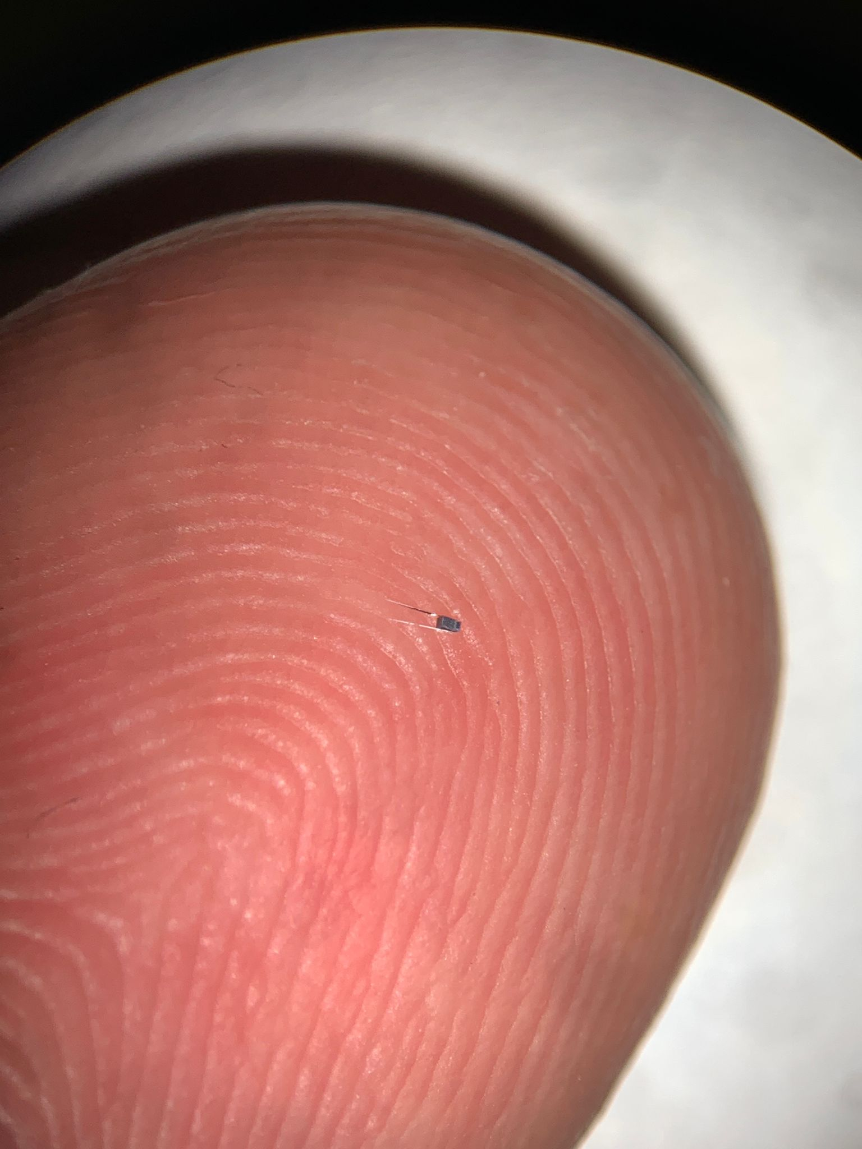
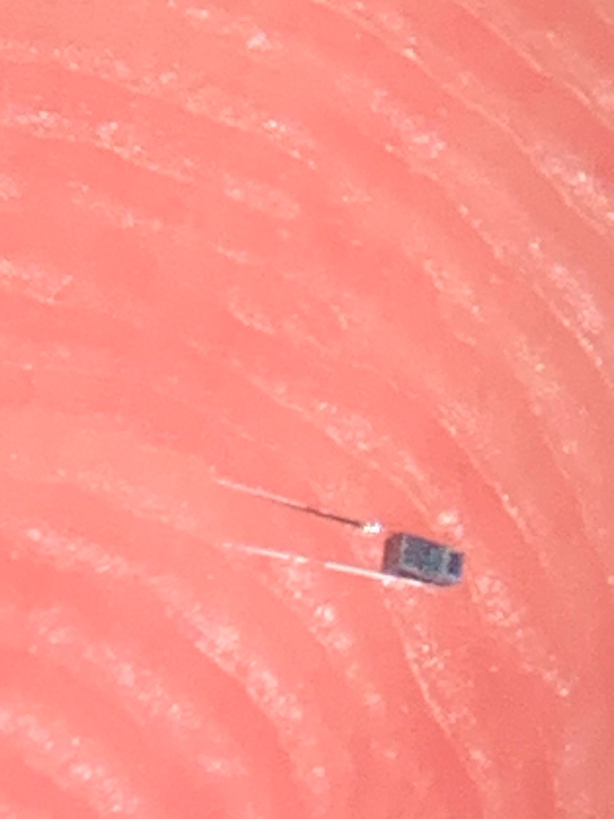
Fig. 1 : Two microelectrode integration processes : (a) microfabricated CMOS-compatible dusts and (b) FIB-based procedure.
Project Description:
In this context, solutions are desirable toward new compact method for microelectrode integration in CMOS-based neural implants. In this regard, two methods seem to be promising. The first one proposes a fully-CMOS compatible process which is based on dry-etching (Fig.1a). The second one involves the use of Focused Ion Beam (FIB) in a particular configuration in order to link the microelectrode with the pad (Fig.1b).
Project Tasks:
- Review the most common methods for microelectrode integration in miniaturized system.
- Design: study the optimal process flow for the CMOS-compatible/FIB procedure.
- CMi Microfabrication: Realize the prototype of CMOS-compatible/FIB-based integrated microelectrode.
- Interface characterization and measurements.
Eligibility Requirements:
- Basic knowledge on microfabrication processes.
- Basic knowledge of 3D modelling/CAD systems (e.g., AutoCAD).
- Interest, Motivation, and Commitment to the project.

