Drugs Detection Simulator
**** Master Project ****
Contacts: Sandro Carrara
Danilo Demarchi

This project targets future developments of new point-of-care systems based on machine learning and electrochemical sensors, for the prediction of therapeutic doses in the blood of oncological patients, for applications to precision medicine.

Within the frame of this project, conscious of the typical issue about large database in machine learning, a simulator will be built in order to supply synthetic data to the machine learning, knowing that previous work have already demonstrated the robustness of such an approach. Our simulator will be based on anticancer treatments protocols dealing with the agents considered in this project, related pharmacokinetics models, and a theory about drug interactions on electrochemical sensors I have established years ago. The simulator will consider inputs from electrochemical biosensors array, and information about the therapy and the patient’ characteristics. The outputs of the simulator will be indeed the simulated currents as coming from electrochemical biosensors to detect anticancer compounds usually used in chemotherapeutic treatments.

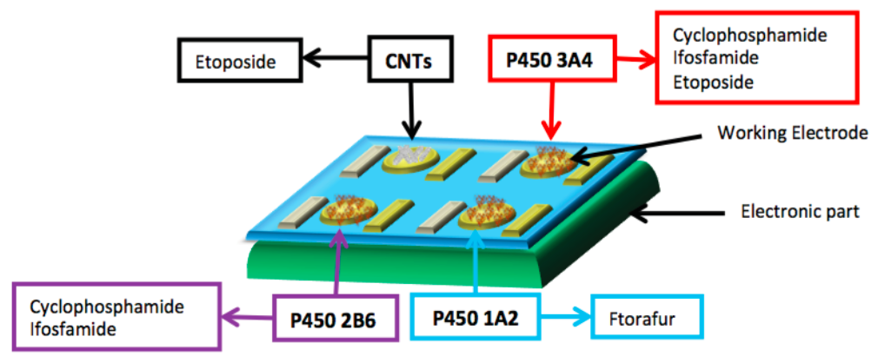
Typical scheme of a multi-drugs detection system based on enzymatic electrochemical sensors

Eligibility Requirements:
- Basic knowledge on sensors
- Basic knowledge of simulations/modeling systems (e.g., MatLab, C-programming, etc…)
- Interest, Motivation, and Commitment to the project
References
Baj-Rossi, Camilla, De Micheli, Giovanni, & Carrara, Sandro, A linear approach to multi-panel sensing in personalized therapy for cancer treatment. IEEE Sensors Journal, 13(2013), 4860-4865: https://ieeexplore.ieee.org/abstract/document/6568871

