CMOS IC Designer for low-power Electrochemical Wearable Biosensors
**** Master Project ****
Contacts: Gian Luca Barbruni
Ata Golparvar
Sandro Carrara

Wearable biosensing technologies show promise for early diagnosis and timely intervention in various health conditions. However, their development has lagged the rapid advancements seen in physiological electrodes and sensors. Currently, the only commercially available wearable device for continuous biosensing is designed for glucose monitoring in interstitial fluid using a microneedle system. While there are alternative non-invasive solutions, there remains a critical need for low-power application-specific integrated circuits (ASICs). These circuits can greatly enhance wearability, extend battery life, and improve the signal quality.

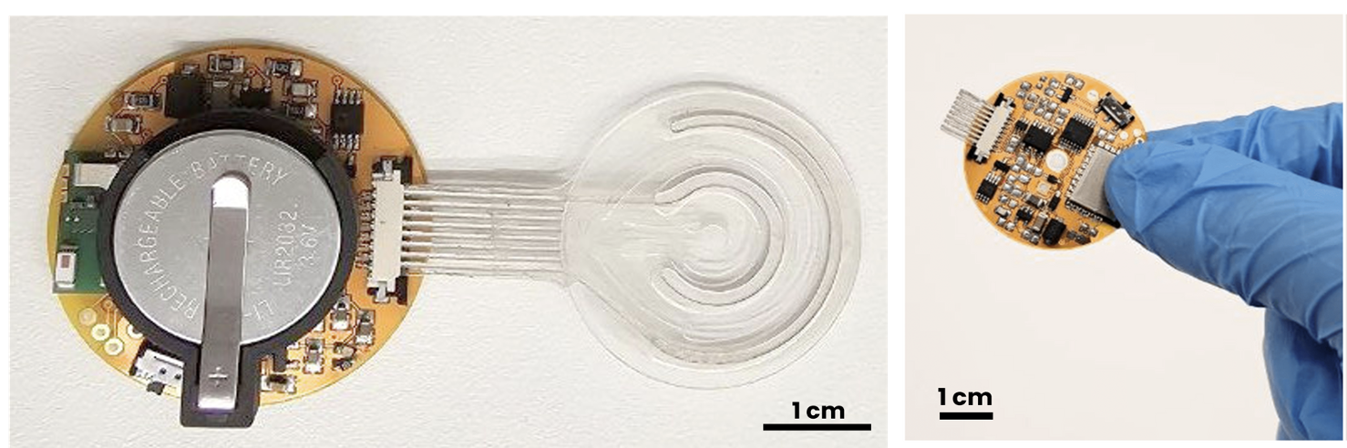
Project Description:
Our mission is to bridge this gap and drive the development of next-generation wearable biosensors. This project aims to find innovative circuit solutions for electrochemical sensor readout as well as on-demand and timely biofluid extraction. The student will concentrate on developing low-power and low-noise CMOS solutions for practical medical engineering applications in close collaboration with biotechnologists, biosensor developers, and embedded system engineers. The ASIC to be designed will encompass battery power management components (such as regulators and DC-to-DC converters), electrochemical sensor readout mechanisms (including oscillators, amplifiers, ramp generators, multiplexers, and analog-to-digital converters), and signal conditioning for data transmission (such as Bluetooth low-energy).

We offer the possibility to be hired after the master’s thesis project.

Project Tasks:
- Investigate the state-of-the-art of low-power ICs for electrochemical biosensor readout.
- Design CMOS circuits suitable for prototype implementation (tape-out).
- Perform CADENCE post-layout simulations to assess the performance of the design.
Eligibility Requirements:
- Basic knowledge of electronics and circuit design.
- Basic knowledge of CAD systems (e.g. CADENCE).
- High motivation for developing biomedical circuits and systems.
References:
- Chien, Jun-Chau, et al. "Design and analysis of a sample-and-hold CMOS electrochemical sensor for aptamer-based therapeutic drug monitoring." IEEE journal of solid-state circuits 55.11 (2020): 2914-2929.
https://ieeexplore.ieee.org/abstract/document/9198904
- Tu, Jiaobing, et al. "A wireless patch for the monitoring of C-reactive protein in sweat." Nature biomedical engineering 7.10 (2023): 1293-1306.
https://www.nature.com/articles/s41551-023-01059-5

