NPK Sensor: How to Detect NPK in the Soil
**** Master Project ****
Contacts: Victor Grimblatt
Danilo Demarchi
Sandro Carrara
Introduction
Crops are the basis of our alimentation, and several factors are affecting their availability. A growing population combined with less arable land and climate change impose the need of smart agriculture to get the best productivity from the soil we are using to grow crops. The growth and health of crops depend on different variables that we need to measure. One of those variables is the nutrients available for plants.

Plants need nutrients to grow healthy. In general, nutrients are added through fertilizers when their availability in the soil is not enough for the considered species. Sixteen chemical elements are known to be important to a plant’s growth and survival. They can be divided in Mineral and Non-Mineral. The non-mineral are:
- Hydrogen (H),
- Oxygen (O),
- Carbon (C).

Through photosynthesis, using sun light as energy, the plant converts CO₂ and H2_{O} into starches and
sugars. Non mineral nutrients are not easy to control. The mineral nutrients come from the soil and are
absorbed by the plant through the roots. There are two types: macronutients and micronutriens.
- Macronutrients,
  - Primary: Nitrogen (N), Phosphorous (P), and Potassium (K),
  - Secondary: Calcium (Ca), Magnesium (Mg), and Sulfur (S).
- Micronutrients: Boron (B), Copper (Cu), Iron (Fe), Chloride (Cl), Manganese (Mn), Molybdenum (Mo), and Zinc (Zn).

Nowadays farmers apply fertilizers to ensure that crops have enough NPK nutrients, however they do that without any knowledge about the quantity they have to apply based on crop specie and the NPK availability in the soil. Over fertilization and under fertilization impacts negatively the productivity of the soil, so it is important to be able to measure the availability of nutrients and to inform the farmer so he can fertilize the soil according to the data he is receiving

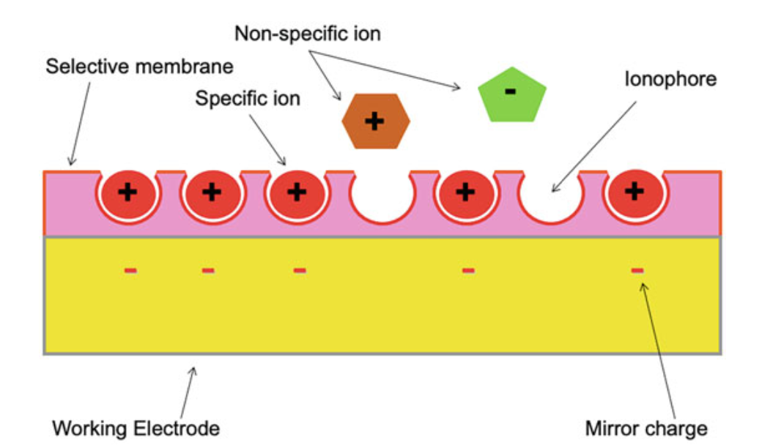

Project Aim
Towards the above-mentioned goal, this Master project aims to investigate the design and implementation of a NPK sensor that will measure in real time the presence of the nutrients in the soil and will provide the available amount per nutrient. The target of the project is to investigate the feasibility of a real time sensor and the implementation of a prototype of the sensor. The sensor should provide data to a processing system that will analyze it and provide an advice to the farmer through a mobile application. Then, the project will move to the design and implementation of a sensor to measure in real time the NPK availability in the soil.

Project Tasks
- Investigate the state-of-the-art of NPK sensors and measurement
- Design a real time NPK sensor
- Implement a prototype of the sensor
- Implement a mobile application to collect and process the data from the sensor and provide information to the farmer

Eligibility Requirements:
- Basic knowledge on electronics and optics
- Interest, Motivation, and Commitment to the project
References
https://ieeexplore.ieee.org/abstract/document/10331913
https://pubs.rsc.org/en/content/articlehtml/2024/ra/d4ra00034j
http://ieomsociety.org/proceedings/2021monterrey/554.pdf

