Platinum Nanostructured Electrode-Based Biosensors for Point-of-Care Applications
Contacts: Francesca Rodino (francesca.rodino@epfl.ch)
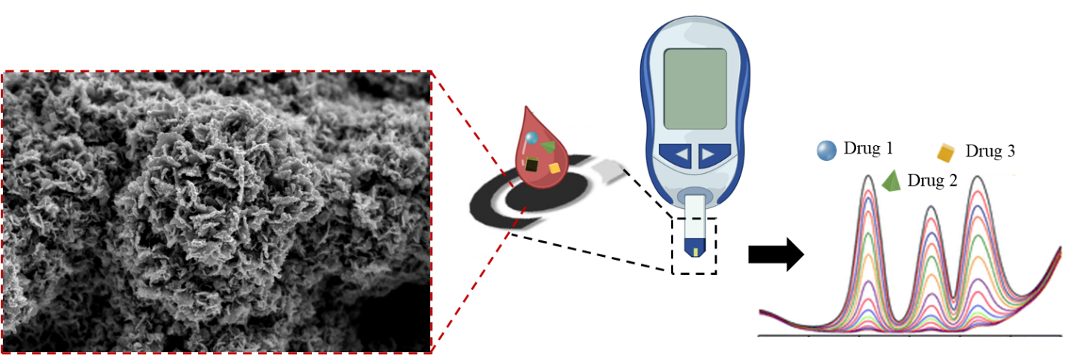
Sandro Carrara (sandro.carrara@epfl.ch)

Introduction
Therapeutic drug monitoring (TDM) is crucial for achieving more precise and personalized medicine, as it accounts for individual differences in metabolism, drug absorption, and response. To this end, real-time monitoring of drug concentrations is crucial to tailoring treatments effectively.
Point-of-care (POC) technologies offer an ideal solution for TDM. In this context, biosensors play a pivotal role by providing rapid and accurate measurements of drug levels in the bloodstream. To ensure precision in TDM, these sensors must be highly sensitive and specific to different drugs.
Platinum nanostructured electrodes combined with enzymatic detection represent a promising approach for the next-generation of biosensors. Platinum's nanostructuring enhances sensitivity due to its excellent conductivity and larger active surface area, while enzymatic detection ensures high specificity to different drugs in co-medication cases.
Project Description:
This project aims to develop innovative point-of-care systems utilizing electrochemical sensors and biosensors for therapeutic drug monitoring (TDM) in oncological patients, targeting personalized medicine. The goal of the project is to develop biosensors or a biosensor array based on platinum nanostructures exploiting electrodeposition processes. This will be followed by integrating a specific enzyme, cytochrome P450, to create biosensors with high specificity.
With this project we explore the significant advantages of platinum nanostructures combined with cytochrome P450 to create highly sensitive and specific biosensors for precision oncology.

Topics:
- Development of electrochemical biosensor:
- Fabrication and deposition of platinum nanostructures
- Characterization of the biosensors' performances
- Testing of the biosensors with anticancer drugs
- Simultaneous detection of multiple drugs
Requirements:
- Basic knowledge of electrochemistry
- Basic knowledge of biosensors systems
- Interest, Motivation, and Commitment to the project

References:
[1] Taurino, Irene, et al. "Fast synthesis of platinum nanopetals and nanospheres for highly-sensitive non-enzymatic detection of glucose and selective sensing of ions." Scientific reports 5.1 (2015): 1-10.
[2] Taurino, Irene, et al. "Recent advances in third generation biosensors based on Au and Pt nanostructured electrodes." TrAC Trends in Analytical Chemistry 79 (2016): 151-159.
[3] Rodino, Francesca, Mattia Bartoli, and Sandro Carrara. "Simultaneous and selective detection of etoposide and methotrexate with single electrochemical sensors for therapeutic drug monitoring." IEEE Sensors Letters (2023).

