Lab-on-chip (LOC) based on memristive biosensor for project “in-memory sensing”

Contacts: Junrui Chen, and Sandro Carrara

Introduction:
Silicon nanowire (SiNW) based biosensors offer exceptional sensing capabilities. When configured in a back-to-back diode structure, SiNWs exhibit diverse memristive behaviors in the current-voltage (I-V) characteristics. These distinct memristive behaviors have a significant impact on the sensing ability of the biosensor. This project is aim to integrate an optimized memristive biosensor with a microfluidic channel, creating a COMS-compatible lab-on-chip system.

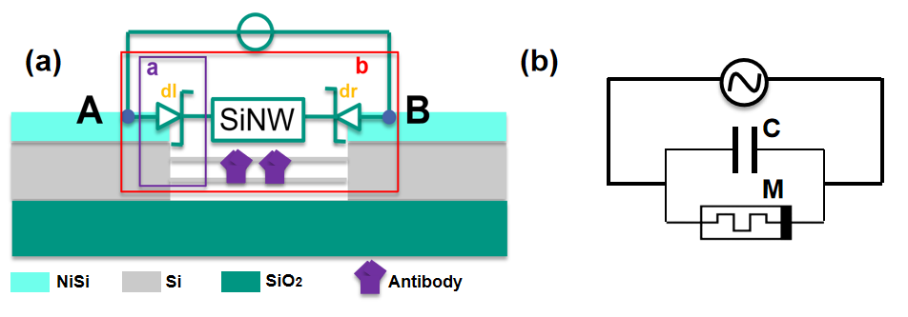
Fig. 1: (a) Schematic of the memristive biosensor, SiNWs are anchored between back-to-back Schottky diodes, bio-modified with antibodies. (b) Equivalent circuit with capacitor shunted to the memristor.

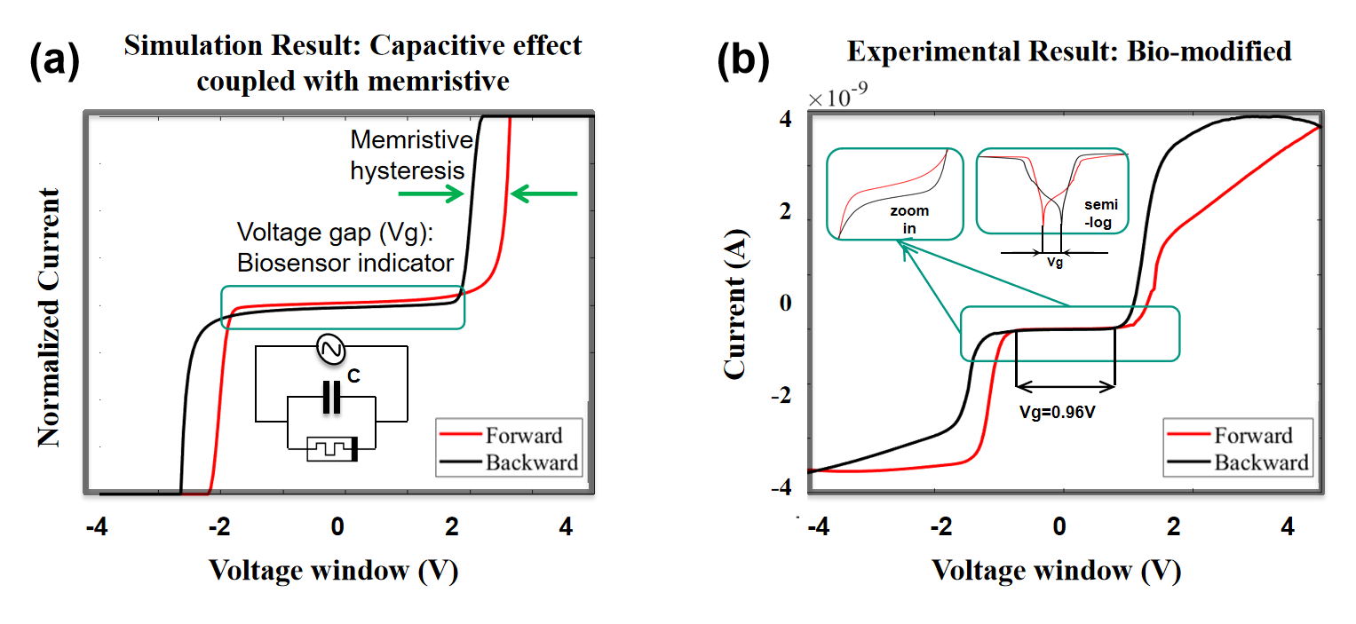
Fig. 2: Voltage gap resposne after biofunctionalization. (a) Simulation result . b) Representative experimental measurement of I-V curve after biofunctionalization.

Objective:
The primary objective of this master project is to conceive, design, and showcase a portable memristive biosensor system. This system will feature a Silicon Nanowire (SiNW)-based memristive biosensor seamlessly integrated into a user-friendly microfluidic platform. The integration will be accomplished in conjunction with a COMS-compatible circuit, culminating in the development of a lab-on-chip system tailored for point-of-care applications.
Student 1: Circuit and Instrument implantation to demonstrate the memristive behavior (Current amplifier, sinus input).
Student 2: Microfluidic channel development, integrating the SiNW based biosensor and electrodes.

Requirement:
For student 1: Basic knowledge on sensors,
Basic knowledge of electronics
Interest, Motivation, and Commitment to the project
For student 2: Knowledge in micro/nano technology, experience in the clean room better.
Interest, Motivation, and Commitment to the project

What can you get probably:
- Knowledge about memristive behavior and memristive biosensor.
- Open-mind colleagues and excellent group.
- 1~2 journal paper together, or 1 conference paper each.

References
- Tzouvadaki, Ioulia, et al. "Portable memristive biosensing system as effective point-of-care device for cancer diagnostics." 2018 IEEE International Symposium on Circuits and Systems (ISCAS). IEEE, 2018.
- Vallero A, Tzouvadaki I, Puppo F, et al. Memristive biosensors integration with microfluidic platform[J]. IEEE Transactions on Circuits and Systems I: Regular Papers, 2016, 63(12): 2120-2127.

