Biofuel Cell: Energy Harvesting

for Implantable Devices
**** Master Project ****
Contacts: Sandro Carrara
Gian Luca Barbruni
Ali Meimandi

The technical field of the project relates to the powering of implantable devices, such as ultra-miniaturized implants, for achieving a micrometer-sized autonomous sensing, computing, and communication system.

Biofuel cells represent a ground-breaking advancement in bioelectronic engineering, as they enable the conversion of the chemicals present in the human body into a reliable source of electrical energy. Biofuel cells would make it possible to create a 'self-powered' implantable medical device, thus independent of a battery or any form of external energy.
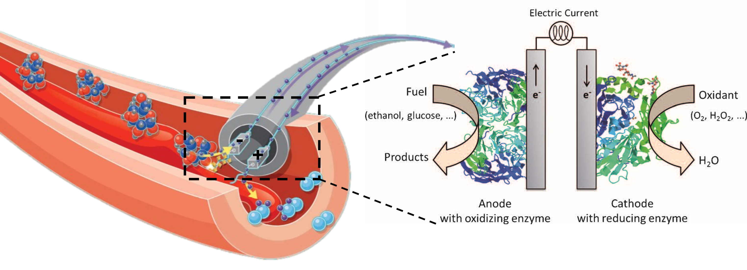
Project Description:
In this context, the aim of this master's project work is to develop an energy harvesting system using endogenous metabolites, such as glucose. To optimize the functionality of the system, an investigation into different nanomaterials and enzymes will be considered. Additionally, the electrical characterization of the biofuel cell will be performed.
Targeting the aim of this project:
- The literature review will be needed to reach a comprehensive choice of materials.
- Electrochemical experiments will be done to design the system.
- Electrical analysis is performed to characterize the designed biofuel cell.
Eligibility Requirements:
- Basic knowledge of biosensors and electrochemistry
- Basic knowledge of electronics
- Interest, Motivation, and Commitment to the project
References:
- Luz, Roberto AS, et al. "Enzyme biofuel cells: thermodynamics, kinetics and challenges in applicability." ChemElectroChem 1.11 (2014): 1751-1777.
- Yang, So‐Yoon, et al. "Powering implantable and ingestible electronics." Advanced functional materials 31.44 (2021): 2009289.
- Garland, Nate T., Rajaram Kaveti, and Amay J. Bandodkar. "Biofluid‐Activated Biofuel Cells, Batteries, and Supercapacitors: A Comprehensive Review." Advanced Materials (2023): 2303197.

