Microfabrication and validation of CMOS-compatible microelectrodes
**** Retributed Internship for Graduate Student ****
Contact: Gian Luca Barbruni
(gianluca.barbruni@epfl.ch)

Miniaturised and wirelessly powered devices are the future of implantable technology. The integration between CMOS-based electronics and neural interface (i.e., penetrating microelectrodes) is extremely challenging. Nowadays, microelectrodes are usually manually attached to the CMOS-pads. This method is user dependent, has low reliability and repeatability.
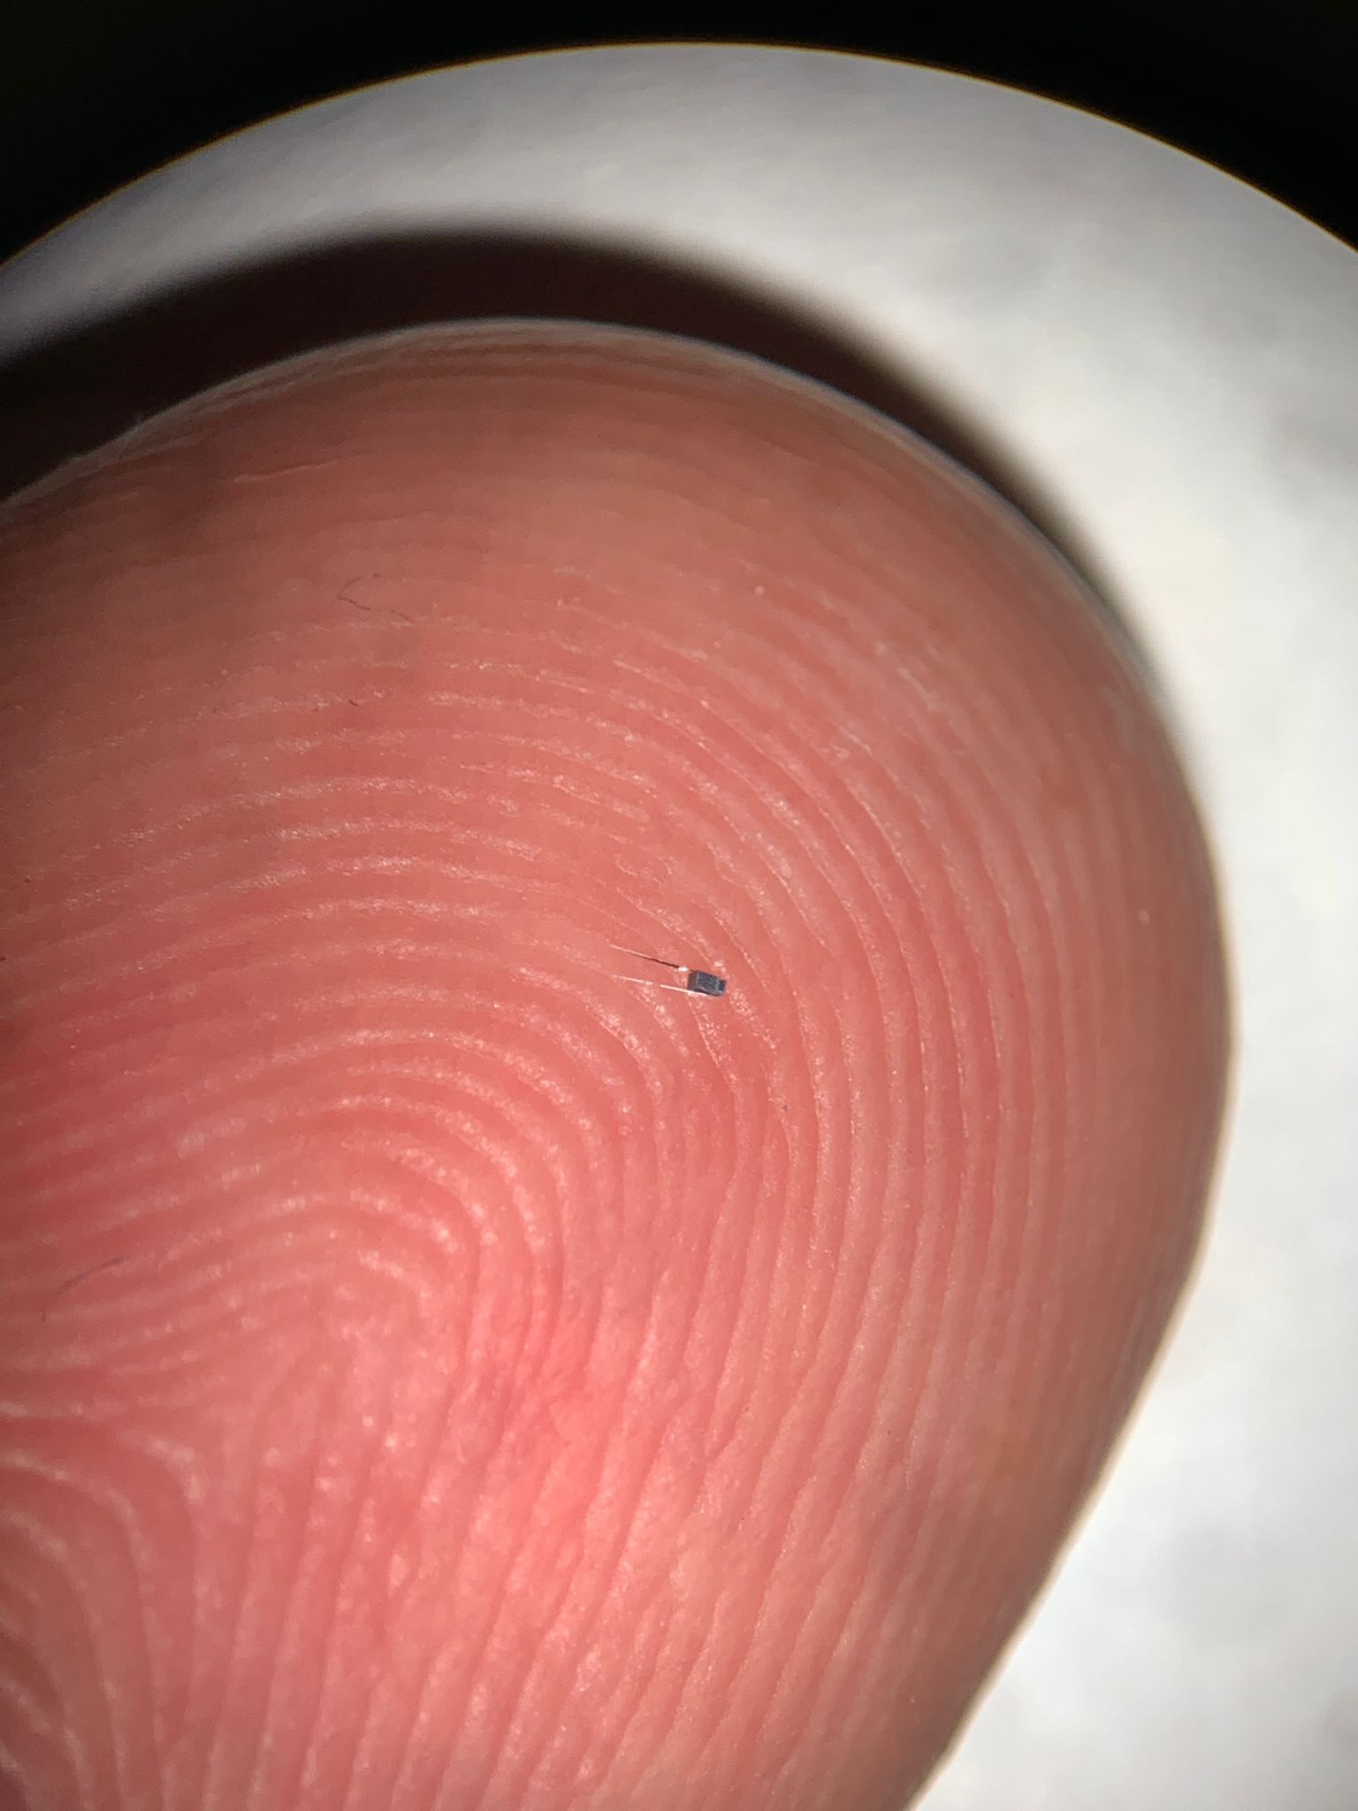
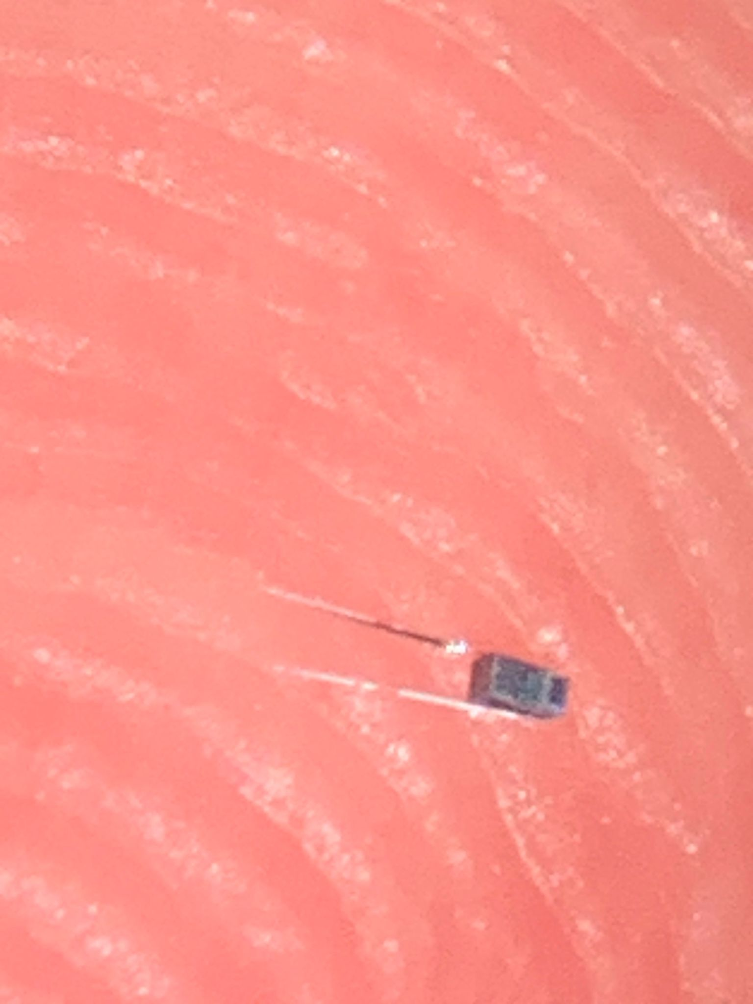
Figure 1: Left: Microelectrode fabrication process idea. Right: First realised prototype compared to human fingerprints.
Project Description:
MINT-CMOS (Microelectrodes INTegrated with CMOS) is an innovative technology which enables the co-fabrication of the neural interface with the electronics. The innovative method is CMOS compatible, favoring wireless and ultra-miniaturised systems.

Internship Description:
- Mechanical simulation of the microelectrode’s folding and insertion in a brain tissue.
- Designing and making of prototypes: cleanroom-based microfabrication of the microelectrodes following different design optimization parameters (i.e., thicknesses of the involved materials).
- Development of a method for reliable bending of the microelectrodes.
- Validation of the methodology by implanting the fabricated microelectrodes into agarose-based brain phantoms and/or in vivo.
Profile and Qualifications:
- A graduate student with a MSc. or experience in microfabrication techniques, materials and thin-film processes (i.e., photolithography, sputtering, PECVD, dry etching, grinding).
- Basic knowledge in neuroengineering and neural interfaces.
- Knowledge of 3D modelling/CAD systems (e.g., AutoCAD).
- Familiarity with mechanical simulations (e.g., COMSOL Multiphisics).
- Interest, Motivation, and Commitment to the project.

Internship Details:
- Retributed Internship.
- EPFL Workplace: Switzerland, Neuchâtel (Microcity) and Lausanne (CMi).
- Duration: 6 months internship starting from 01.02.2023 (possibility to start before).

Links:
- ICLAB - BCI group https://www.epfl.ch/labs/iclab/index-html/bci-group/
- LNE https://www.epfl.ch/labs/lne/

