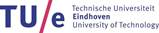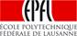

Joint Supervison Doctorate
between
Eindhoven University of Technology
and
Ecole polytechnique fédérale de Lausanne
partners of
Euro Tech Universities

