My research explained…
[Title of my research]

[Name, surname] / [Laboratory]

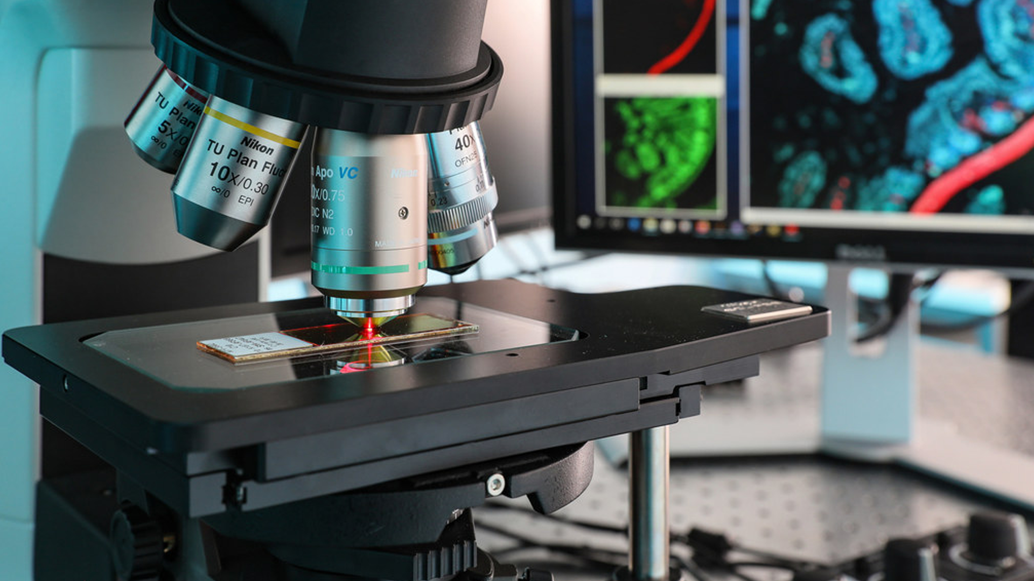
Image 1920 x 1080

  - Summary
400 characters max.

  - Objectives
1000 characters max.

  - How does it work?
1000 characters max.

  - What is the purpose?
1000 characters max.

  - More information available…
[Link to webpage]

