Safety and Compliance Documentation for “Homemade” Work Equipment
Scope and Objectives:
In the absence of certification by a qualified safety engineer or an accredited body, designers and manufacturers of homemade equipment at EPFL must ensure that their constructions comply with basic health and safety rules:
- Ordinance on Product Safety (OSPro)
- CFST Directive 6512 'Work Equipment'
- Ordinance on Machine Safety (OMach)
- DIRECTIVE 2006/42/EC on machinery
- Ordinance on the Prevention of Accidents and Occupational Diseases (OPA)
- Purchase of Work Equipment – Safety Starts at the Time of Purchase! SUVA
All homemade work equipment must be accompanied by:
1 | User manual written in the users’ language. This manual must include:  - Detailed operating procedures:  - Normal operation: routine use of the equipment  - Special operation: adjustments, cleaning, troubleshooting  - Maintenance: inspection, servicing, restoration  - Foreseeable misuse  - Information regarding residual risks  - Instructions for transport, installation, and assembly  - Personal protective equipment (PPE) that must be worn when using the equipment.  - Specific training that users must undergo.
2 | Standard Operating Procedure (SOP) for the experiment - Template provided in Annex 1
3 | List of needed personal protective equipment and proper usage and maintenance instructions
4 | Training record (covering hazards, risks, and proper equipment use) - Template provided in Annex 2. The training record must include the trainer’s name and key topics to be covered.
5 | Declaration of conformity - template provided in Annex 3: a declaration by the manufacturer confirming that the machine complies with all applicable Swiss safety, health, and environmental regulations.  This declaration confirms that:  - Hazard assessment has been conducted, and appropriate protective measures have been implemented  - It meets the applicable Swiss laws and technical standards  - The manufacturer (head of the research unit) takes responsibility for its conformity  The declaration must be signed by the person responsible (group leader) and kept available for inspection by authorities.
6 | Identification of hazards and proposed protective measures: systematic identification of all potential hazards (mechanical, electrical, chemical, biological, etc.) related to the equipment and activities, with corresponding preventive measures to eliminate or minimize risks.

Identification of hazards and associated protective measures
Please specify the type of protective measure in the left column or indicate “Hazard not present” if the hazard does not apply to your equipment.
Mechanical hazards: crushing, shearing, and entanglement zones | Proposed protective measures
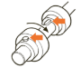
Rotating shafts with protruding parts
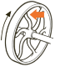
Pulleys or flywheels with openings
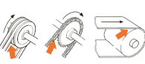
Belt or chain engagement zones
Drive or nip points of rotating parts (cylinders, gears)
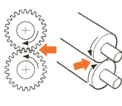


Wheels of mobile equipment presenting a crushing hazard for hands or feet

Rotating parts (worm screws, fan blades, rotors)
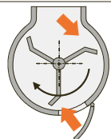
Shearing zone created by sliding éléments
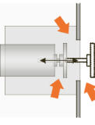
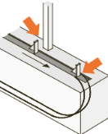

Component presenting a crushing hazard at the end of its stroke
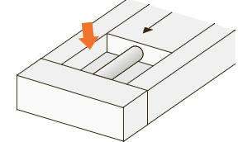
Crushing or shearing zone created by a lever or drive arm
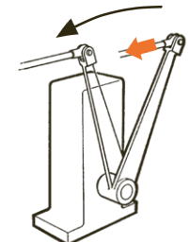
Mechanical Hazards: Sharp Elements | Proposed protective measures
Sharp or pointed objects: saw blades, milling cutters, grinding wheels, bands
Presence of sharp edges on objects that must be handled
Mechanical Hazards: Uncontrolled Moving Parts | Proposed protective measures
Tipping, swinging, rolling, sliding
Unintended switch-on
Pressurized fluids
Objects at height
Risks of falls and trips | Proposed protective measures
Working at height, changes in level
Slippery surfaces, stumbling, poor visibility conditions
Electrical Hazards | Proposed protective measures
Exposed live parts > 12 mm in diameter
Electrostatic phenomena
Risk of short circuits, overloads, electrical arcs
High current:
Voltage > 50 Vac or 120 Vdc
Current > 2 A
High voltage:
1000 Vac or 1500 Vdc
Low and extra-low voltage:
< 1000 Vac or 1500 Vdc
Low current:
Voltage < 50 Vac or 120 Vdc
Current < 2 A
Power supply failure | Proposed protective measures
Control function failure (e.g., valve stuck in an undefined position)
Cooling system failure (e.g., pressure increase)
Flammable or explosive substances | Proposed protective measures
Liquids, dust, gases, solids, aerosols
Explosive atmosphere
Explosives
Ignition sources
Biological hazards | Proposed protective measures
Use of microorganisms (viruses, bacteria, parasites, fungi, cell cultures, etc., human or animal samples) with biosafety level 2, 3, or 4.
Use of genetically modified organisms
Use of exotic organisms (not naturally present in Switzerland)
Use of microbial or biologically derived toxins
Use of infectious proteins, such as prion-like proteins
Thermal Hazards | Proposed protective measures
Open flame
Hot or cold surfaces or environments
Projection of hot or cold materials
Physical hazards | Proposed protective measures
Noise (continuous or sudden)
Ultrasound/infrasound
Non-ionizing radiation (visible and ultraviolet light, lasers, electromagnetic fields, infrared)
Ionizing radiation (X-rays, radioactive substances)
Vacuum or overpressure
Musculoskeletal disorders | Proposed protective measures
Forced posture
Strenuous movements
Lifting and handling heavy objects
Repetitive activities
Vibrations (transmitted to the whole body, hand, or arm)
Constraints related to the work environment | Proposed protective measures
Climate, weather conditions
Heat, cold
Indoor climate
Lighting
Working alone | Proposed protective measures
Isolated worker (e.g., outside standard working hours)
Chemical hazards | Proposed protective measures
Chemicals with GHS pictograms, use of nanoparticles (size and shape), compressed gases

The location of the work equipment
For very heavy equipment, it is essential to verify that the load-bearing capacity is adequate (for example, ensuring that the floor slabs can support the weight). In addition, the location of the equipment must not create new hazards (e.g. obstruction of evacuation routes, logistics paths, or access to emergency equipment).

Identification of residual risks
Residual risks are those that persist despite the implementation of effective risk reduction measures.
Identified residual risk | Users must be informed of the residual risks

Hazard, obligations and prohibition pictograms
Standardized pictograms must be visibly displayed on the machine to indicate potential hazards and the corresponding safety measures.
Examples:
Hazard pictograms | 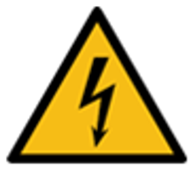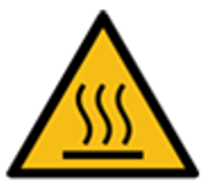
Obligations pictograms | 
Prohibition pictograms | 

Annex 1
Required elements for a Standard Operating Procedure (SOP)
- Persons responsible for the experiment (in addition to the group leader) | Full name of the responsible person
- Purpose of the experiment (a few lines)  - Process diagram (as in the example below), and provide the following information:  - Names of the equipment (e.g. type of reactor, pump, reflux system, Schlenk line, cooling system, heating system, etc.)  - Chemical reactions involved, if any, with reagents, products, and catalysts (if applicable)  - Concentration and composition in case of mixtures  - Inlet and outlet flows with their flow rates, pressure, and names for each operation (e.g. gas or liquid)  - Essential valves  - Positions and types of sensors used for process control  - Information on operating conditions  - Equipment specifications  - Height levels and relative vertical positions of the equipment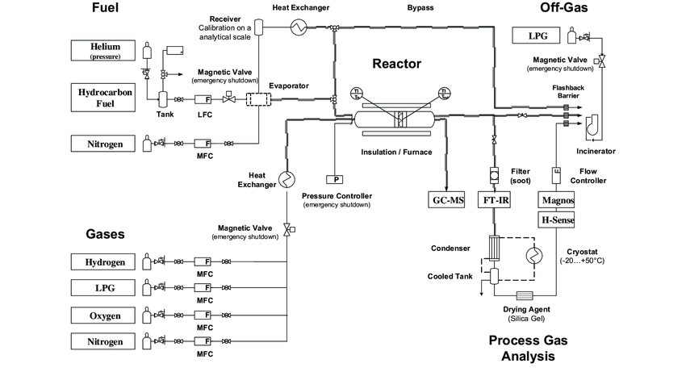 | The researcher must submit the SOP including all elements 1 -7 listed in the left-hand columns.
- Complete procedure (full usage protocol)
- PPE (personal protective equipment)
- Waste management procedure
- Emergency procedure
Is a chemical fume hood available? | Yes ☐ No ☐
Are gas cabinets available? | Yes ☐ No ☐
Is there a fixed gas detector in the laboratory, and what type is it? | Yes ☐ No ☐
The SOP must be updated in case of any changes.
Annex 2
Training Record for Work Equipment

General informations

Training Title
Training Date
Location
Equipment Name
Manufacturer - Model
Instructor - Name and Role

First name, last name of trained people

First name | Last name | Signature

Training content

☐ Normal and specific usage conditions (adjustments, troubleshooting, cleaning)
☐ Foreseeable incidents during work (common breakdowns)
☐ Checks of safety devices performed by workers
☐ Predictable risks during work (existing hazards and related activities)
☐ Use of personal protective equipment (PPE)
☐ Emergency stop procedure
☐ Verification of practical knowledge
☐ Others

Annex 3
Declaration of Conformity
We, | Full name of the research unit, and address
hereby declare that the

Product
Type
Serial number
We have thoroughly assessed the hazards associated with the use of equipment and implemented all necessary preventive measures.  Completion of the document ‘Safety and Compliance Documentation for Homemade Work Equipment’ demonstrates that the essential requirements of the following Ordinances and Directives are met. | Ordinance on the Prevention of Accidents and Occupational Diseases (OPA), Product Safety Act (LSPro), the CFST Directive 6512 “Work Equipment”, and the Ordinance on the Safety of Machinery (OMach; RS 819.14).
Individuals who conducted the hazard assessment, implemented protective measures, drafted the user manual and developed the Standard Operating Procedure (SOP). | Full names
Harmonized standards and other technical standards and specifications applied, if any: | Examples:  - EN ISO 12100:2010 (design of safe machinery)  - EN ISO 13849-1:2015 (design and integration of control systems)  - EN ISO 13849-2:2012 (safety-related control systems)  - EN 60204-1:2006 (electrical equipment of machines)
Date and signature of the group leader.
The head of the research unit is regarded as the manufacturer and assumes full responsibility for ensuring the equipment's conformity with applicable regulations.

